VIETNAM GENERAL CONFEDERATION OF LABOR

**TON DUC THANG UNIVERSITY**

**FACULTY OF ELECTRICAL AND ELECTRONICS ENGINEERING**



**Dinh Nguyen Gia Phu**

**DESIGN AND IMPLEMENT A ROBOT ARM FOR SORTING PRODUCTS BY COLOR AND SHAPE**

**UNDERGRADUATION THESIS**

**AUTOMATION AND CONTROL ENGINEERING**

**HO CHI MINH CITY, YEAR 2024**

VIETNAM GENERAL CONFEDERATION OF LABOR

**TON DUC THANG UNIVERSITY**

**FACULTY OF ELECTRICAL AND ELECTRONICS ENGINEERING**



**Dinh Nguyen Gia Phu – 420H0265**

**DESIGN AND IMPLEMENT A ROBOT ARM FOR SORTING PRODUCTS BY COLOR AND SHAPE**

**UNDERGRADUATION THESIS**

**AUTOMATION AND CONTROL ENGINEERING**

Advised by

**MSc. Thieu Quang Tri**

**Ho Chi Minh City, YEAR 2024**

**ACKNOWLEDGMENTS**

No successful work is achieved without one's effort and dedication, as well as the help and support of teachers, friends, and colleagues around them. Therefore, I need to thank many wonderful people for their dedication and help in this project.

I would like to send my sincere thanks and good wishes to the esteemed teachers at Ton Duc Thang University who have devotedly instructed us during the past period. I thank the teachers in the Faculty of Electrical and Electronics, the Automation Department, and especially MSc. Thieu Quang Tri for guiding me in completing this undergarduation thesis and helping me to gain more knowledge. This project would not have been completed without the help of the teachers. Due to my lack of experience and understanding, there may be mistakes that I hope the teachers will overlook and provide advice and guidance for me to draw experiences and complete the upcoming project. I sincerely thank you all.

Finally, I would like to thank my parents and family for always accompanying and supporting me during the project.

*Ho Chi Minh City, July 18, 2024*

*Author*

*Dinh Nguyen Gia Phu*

**This thesis was caried out at Ton Duc Thang University**

**Advisor : MSc. Thieu Quang Tri**

This thesis is defended at the Undergraduate Thesis Examination Committee was hold at Ton Duc Thang University at … /…/……

Confirmation of the Chairman of the Undergraduate Thesis Examination Committee and the Dean of the faculty after receiving the modified thesis (if any).

**CHAIRMAN DEAN OF FALCUTY**

**DECLARATION OF AUTHORSHIP**

I hereby declare that this thesis was carried out by myself under the guidance and supervision of MSc. Thieu Quang Tri; and that the work and the results contained in it are original and have not been submitted anywhere for any previous purposes. The data and figures presented in this thesis are for analysis, comments, and evaluations from various resources by my own work and have been duly acknowledged in the reference part.

In addition, other comments, reviews and data used by other authors, and organizations have been acknowledged, and explicitly cited.

**I will take full responsibility for any fraud detected in my thesis.** Ton Duc Thang University is unrelated to any copyright infringement caused on my work (if any).

*Ho Chi Minh city , July 18, 2024*

Author

Dinh Nguyen Gia Phu

**Design and implement a robot arm for sorting products by color and shape**

**ABSTRACT**

In the era of Industry 4.0, robotic arms play a crucial role in automation and productivity enhancement across various fields. Designed to adapt to specific tasks, they are increasingly becoming an indispensable part of the industry and other application areas. Therefore, this topic has been chosen for further research and development in this field.

The project uses key components such as Raspberry Pi 4, Arduino Uno R3, and ESP32. The Raspberry Pi 4 is used as the main processor, receiving and processing images from the camera to identify the shape and color of products. The Arduino Uno R3 controls the robotic arm, executing movements based on image processing results. The ESP32 and two infrared sensors are used to control the conveyor belt, ensuring it starts and stops at the right times to maintain process continuity.

The content of the project includes designing a 3-DOF robotic arm model using Mathlab software, implementing hardware with Raspberry Pi 4 and Arduino Uno R3, and developing a web interface using Node-RED and MQTT. The web interface will allow users to start, stop, and monitor the robot's operational status, as well as the quantity of sorted products. The image processing system on the Raspberry Pi 4 will identify the shape and color of the products and then send control commands to the Arduino to perform the appropriate movements.

The desired outcome of the project is to build an efficient and modern automation system capable of accurately and quickly sorting products by shape and color. This system will help improve productivity and reduce errors in the production process. Additionally, a user-friendly web interface will enable users to easily monitor and control the system, providing convenience and flexibility in operation.

**Thiết kế và thi công cánh tay robot phân loại sản phẩm theo màu sắc và hình dạng**

**Tóm tắt**

Vào thời kì công nghiệp 4.0, cánh tay robot đóng vai trò quan trọng trong việc tự động hóa và tăng cường năng suất trong nhiều lĩnh vực khác nhau. Được thiết kế để thích ứng với các nhiệm vụ cụ thể, chúng đang ngày càng trở thành một phần không thể thiếu trong ngành công nghiệp và các lĩnh vực ứng dụng khác. Vì vậy đề tài này được lựa chọn nghiên cứu và phát triển thêm về lĩnh vực này.

Đề tài sử dụng các thành phần chính như Raspberry Pi 4, Arduino Uno R3, và ESP32. Raspberry Pi 4 được sử dụng làm bộ xử lý chính, nhận và xử lý hình ảnh từ camera để xác định hình dạng và màu sắc của sản phẩm. Arduino Uno R3 điều khiển cánh tay robot, thực hiện các chuyển động dựa trên kết quả xử lý ảnh. ESP32 và hai cảm biến hồng ngoại được sử dụng để điều khiển băng chuyền, đảm bảo băng chuyền chạy và dừng đúng lúc để đảm bảo sự liên tục của quy trình.

Nội dung đề tài bao gồm việc thiết kế mô hình cánh tay robot 3 bậc tự do bằng phần mềm Mathlab, triển khai phần cứng với Raspberry Pi 4 và Arduino Uno R3, và phát triển giao diện web sử dụng Node-RED và MQTT. Giao diện web sẽ cho phép người dùng khởi động, dừng, và theo dõi trạng thái hoạt động của robot, cũng như số lượng hàng hóa đã được phân loại. Hệ thống xử lý ảnh trên Raspberry Pi 4 sẽ xác định hình dạng và màu sắc của sản phẩm, sau đó gửi lệnh điều khiển đến Arduino để thực hiện các chuyển động phù hợp.

Kết quả mong muốn của đề tài là xây dựng một hệ thống tự động hóa hiệu quả và hiện đại, có khả năng phân loại sản phẩm theo hình dạng và màu sắc một cách chính xác và nhanh chóng. Hệ thống này sẽ giúp nâng cao năng suất và giảm thiểu sai sót trong quá trình sản xuất. Ngoài ra, giao diện web thân thiện sẽ giúp người dùng dễ dàng giám sát và điều khiển hệ thống, mang lại sự thuận tiện và linh hoạt trong vận hành.

|  |  |
| --- | --- |
| Ton Duc Thang University  **Faculty of electrical - Electronics**  ------------------- | SOCIALIST REPUBLIC OF VIETNAM  Independence - Freedom - Happiness  ----------------------- |

**GRADUATION PROJECT TIMETABLE**

Student’s full name: Đinh Nguyễn Gia Phú

Category: Control Engineering and Automation

Class: 20H40301 Student’s ID: 420H0265

Title: Design and implement a robot arm for sorting products by color and shape

|  |  |  |  |  |  |
| --- | --- | --- | --- | --- | --- |
| **Week** | **Content** | | | **Signature** | |
| **Done** | **Continue** | |
| 1 | Find out and choose a topic | Choose a topic. | |  | |
| 2 | Choose a topic | Research brief information about projects | |  | |
| 3 | Learn about robotic arms | Learn about robotic arms | |  | |
| 4 | Learn step motor | Step angle control | |  | |
| 5 | Learn about Arduino Uno | Write code to control the arm on Arduino ide | |  | |
| 6 | Write code to control the arm on Arduino ide | Continue write code to control the arm on Arduino ide | |  | |
| 7 | Write code to control the arm on Arduino ide | Edit and debug code | |  | |
| Midterm | Completion volume assessment 50%  Allow continuation/non-continuation of DATN implementation | | | | |
| 8 | Learn about image processing | | Learn about python | |  |
| 9 | Learn about python and code image processing | | Continue code image processing | |  |
| 10 | Test run and fix errors code image processing. | | Learn about Node-red and MQTT | |  |
| 11 | Create a monitoring interface on Node-red | | Write code for the monitoring interface | |  |
| 12 | Write code for the monitoring interface | | Continue to fix the interface | |  |
| 13 | Write code interface | | Connecting wires for conveyor, relay, robot arm | |  |
| 14 | Run the model | | Check and fix errors | |  |
| 15 | Write the report | | Finish writing report | |  |
| Submit graduation project | Completed 100 % Graduation Project  Protected/Unprotected Graduation Project | | | | |

TABLE OF CONTENT

LIST OF FIGURE xii

LIST OF TABLE xiv

LIST OF ABBREVIATION xv

CHAPTER 1. INTRODUCTION 1

1.1 Reason for choosing the topic 1

1.2 Implementation objective 1

1.3 Object and scope of the study 3

1.4 Research method 4

1.5 Practical significance 4

1.6 Expected results 5

CHAPTER 2. THEORETICAL BASIS 6

2.1 Overview of the Arduino Uno – Controller board 6

2.1.1 Introduction to Arduino Uno 6

2.1.2 Characteristics of Arduino Uno 6

2.1.3 Function of the ports 7

2.1.4 Board Outline & Mounting Holes 9

2.2 ESP 32 9

2.2.1 Introduction to ESP32 9

2.2.2 Technical Specifications 10

2.3 Raspberry Pi 4 Model B 13

2.3.1 General Introduction 13

2.3.2 Technical specifications 13

2.3.3 Function of the ports 14

2.3.4 Application of Raspberry Pi 4 14

2.4 Driver A4988 16

2.5 Nema 17 Stepper Motor Usongshine 17HS4401 17

2.6 CNC Shield V3 19

2.7 Power source 20

2.8 Limit switch KW11-3Z 21

2.9 Module relay 5V 22

2.10 Webcam Q-2O 23

2.11 Mini Vacuum Pump Brushless Motor 23

2.12 Solidworks 25

2.13 Arduino 25

2.14 Visual Studio Code 26

2.15 UART Communication 27

2.16 MQTT 29

2.17 Node red 32

2.18 Robot 33

2.18.1 Concept 33

2.18.2 Functions of Robots 34

2.18.3 Degrees of Freedom of a Robot Arm 35

2.18.4 Coordinate System 35

2.18.5 Forward Kinematics 36

2.18.6 Inverse Kinematics 37

CHAPTER 3. CALCULATION AND DESIGN 39

3.1 System overview 39

3.2 Robot control 40

3.2.1 Step motor control 41

3.2.2 Pulse Supply for the Motor 42

3.3 Image processing 42

3.3.1 OpenCV library 42

3.3.2 Object identification 44

3.3.3 Region of Interest (ROI) 45

3.3.4 Color processing 45

3.4 Control block diagram, wiring diagram and algorithm flow chart 49

3.4.1 Control block diagram 49

3.4.2 Flow chart 51

3.4.2.1 Algorithm flow chart for image processing 51

3.4.2.2 Algorithm flow chart for Robot arm 52

3.4.3 Wiring dìgram 53

3.4.4 Step-down converter 54

CHAPTER 4. CONSTRUCTION AND EXPERIMENT 55

4.1 Construction 55

4.1.1 Transmission Assembly for the First Rotational Joint 55

4.1.2 Transmission Assembly for the Second Rotational Joint 56

4.1.3 Transmission Assembly for the Third Rotational Joint 57

4.1.4 Gripper Assembly 58

4.1.5 Overview of the Robot arm 58

4.2 Construction of realistic models 59

4.3 Build the display interface 60

4.4 Experimental process 61

4.5 Experimental results 62

CHAPTER 5. CONCLUSION 64

5.1 Advantages 64

5.2 Disadvantages 64

5.3 Development 64

REFERENCES 65

APPENDIX A: ARDUINO SOURCE CODE 1

APPENDIX B: PYTHON SOURCE CODE 8

APPENDIX C: ESP32 SOURCE CODE 16

# LIST OF FIGURE

Figure 2‑1: Arduino Uno R3 Pinout Diagram. 7

Figure 2-2: Side of the board. 9

Figure 2-3: Front side of the board. 9

Figure 2-4: ESP32 10

Figure 2-5: ESP32 pinout. 12

Figure 2-6: Raspberry Pi4. 13

Figure 2-7: Function of the ports of Raspberry Pi4. 14

Figure 2-8: Image of A4988 control circuit. 16

Figure 2-9: Wiring diagram of circuit A4988. 17

Figure 2-10: Stepper motor 17HS4401S. 18

Figure 2-11: Stepper motor 17HS4401S figure. 19

Figure 2-12: CNC Shield V3. 19

Figure 2-13: Power source 12VDC. 20

Figure 2-14: Limit switch KW11-3Z. 21

Figure 2-15: Module relay 5V. 22

Figure 2-16: Webcam Q-2O. 23

Figure 2-17: KVP8-KD-S vacuum pump. 24

Figure 2-18: Solidworks software. 25

Figure 2-19: Arduino software. 26

Figure 2-20: Visual Studio Code. 27

Figure 2-21: Operational model of components in MQTT. 30

Figure 2-22: MQTT publish/subscribe operating model. 32

Figure 2-23: Node-red. 33

Figure 2-24: Robotic arm with 6 degrees of freedom. 35

Figure 2-25: Right hand rule. 36

Figure 2-27: Coordinate system attached to the robot. 36

Figure 3-1:System overview. 39

Figure 3-2: Wiring diagram of circuit A4988. 41

Figure 3-3: Example of image processing. 43

Figure 3-4: Block diagram of image processing. 44

Figure 3-5: H color range in the HSV color system. 46

Figure 3-6: Color model. 47

Figure 3-7: Result of contour approximation function. 48

Figure 3-8: Block diagram. 49

Figure 3-9: Flow chart for image processing. 51

Figure 3-10: Flow chart for Robot arm. 52

Figure 3-10: Wiring diagram of stepper motor control block. 53

Figure 3-11: Wiring diagram of vacuum pump on/off circuit. 53

Figure 3-11: Step-down converter. 54

Figure 3-12: PCB of step-down converter. 54

Figure 4-1: Belt transmission. 55

Figure 4-2: 3D drawing of the first rotary joint. 56

Figure 4-3: 3D drawing of the second rotary joint. 57

Figure 4-4: 3D drawing of the third rotary joint. 57

Figure 4-5: 3D drawing of the Gripper Assembly. 58

Figure 4-6: 3D drawing of the Robot Arm. 58

Figure 4-7: Robot arm is printed from the drawing board. 59

Figure 4-8: Overview of the actual system. 59

Figure 4-9: Interface displayed on node-red. 60

Figure 4-10: Interface code displayed on node-red. 60

Figure 4-11: Put product on conveyor belt. 61

Figure 4-12: Detect color and label shape. 61

Figure 4-13: Web-based control and monitoring. 62

# LIST OF TABLE

Table 2-1: Specifications of Arduino Uno R3. 6

Table 2-2: Analog pins of Arduino Uno R3. 8

Table 2-3: Digital pins of Arduino Uno R3. 8

Table 2-4: Technical specifications of Raspberry Pi4. 13

Table 2-5: Technical specifications of Driver A4988. 16

Table 2-6: Function of ports of Driver A4988. 16

Table 2-7: Sets the microstepping mode for the motor. 17

Table 2-8: Technical specifications of Stepper motor 17HS4401S. 18

Table 2-9: Technical specifications of CNC Shield V3. 20

Table 2-10: Technical specifications of power source. 20

Table 2-11: Technical specifications of limit switch. 21

Table 2-12: Technical specifications of Module relay 5V. 22

Table 2-13: Function pins of Module relay 5V. 22

Table 2-14: Technical specifications of Webcam Q-2O. 23

Table 2-15: Technical specifications of KVP8-KD-S vacuum pump. 24

Table 2-16: Parameters in UART. 28

Table 2-17: Application of UART. 28

Table 4-1: Experimental table of model accuracy. 62

Table 4-1: Experimental table of model accuracy. 63

# LIST OF ABBREVIATION

DOF Degrees of Freedom

MQTT Message Queuing Telemetry Transport

UART Universal Asynchronous Receiver/Transmitter

GPIO General Purpose Input/Output

GUI Graphical User Interface

RPi4 Rasberry Pi 4

PWM Pulse Width Modulation

1. INTRODUCTION

## Reason for choosing the topic

Presently, our nation, along with the rest of the globe, is embarking on the age of 4.0 with the revolution of industrial modernization. The use of industrial gadgets and technology as a substitute for human labor is gaining popularity and has become a worldwide phenomenon. Hence, robotic systems are extensively prevalent and serve a crucial function in both human existence and manufacturing.

This sector utilizes advanced and intricate technologies, combining many technologies into a single product, including as mechanics, artificial intelligence, electrical devices, microcontrollers, and more. During the manufacturing process, this solution aids companies of varying sizes, including small, medium, and big enterprises, in enhancing labor efficiency, maintaining competitiveness in the market, and maximizing the overall value generated for the company.

The rationale for selecting this subject is based on the profound influence of robotic arms in the age of Industry 4.0. With the growing importance of automation in improving production and efficiency in many industries, robotic arms are engineered to carry out precise and adaptable jobs. Our objective is to investigate and provide a valuable contribution to the progress of automation technology, specifically in the area of sorting products based on their form and color. This study not only tackles present-day industry requirements but also lays the groundwork for future advancements in automated systems. The incorporation of components such as Raspberry Pi 4, Arduino Uno R3, and ESP32 showcases the capacity to merge diverse technologies in order to provide a complete and efficient solution for contemporary industrial obstacles.

## Implementation objective

The main objective of this project is to create and execute a 3-degree-of-freedom (DOF) robotic arm that can categorize objects based on their form and color. The implementation prioritizes the integration of several technologies to create a streamlined and contemporary automated system. The implementation aims to specifically address the following objectives:

1. Image Processing and Recognition:

* Employ the Raspberry Pi 4 and its camera to get photographs of the items.
* Apply image processing methods to precisely detect the shape and color of the goods.
* Implement real-time processing to enable efficient and precise sorting.

2. Control of Robotic Arm:

* Utilize Arduino Uno R3 to govern the motions of the 3 degrees of freedom (DOF) robotic arm.
* Create methods that convert image processing outcomes into accurate control instructions for the robotic arm.
* Ensure the robotic arm operates smoothly and efficiently to handle goods of different shapes and colors.

3. Conveyor Belt System:

* Utilize ESP32 and infrared sensors to regulate the functioning of the conveyor belt.
* Ensure the conveyor belt is activated and deactivated at the right intervals to ensure a continuous and efficient process of sorting products.
* Align the operation of the conveyor belt with the robotic arm to enhance the efficiency of the sorting process.

4. Web Interface Development:

* Create an easily navigable web interface by using Node-RED and MQTT.
* Enable users to initiate, terminate, and oversee the operating state of the robotic arm.
* Offer up-to-the-minute information on the amount and categories of sorted merchandise.
* Ensure that the interface is user-friendly and easily accessible for users with different levels of technical expertise.

The research intends to showcase the viability and benefits of using cutting-edge technology in automated sorting systems by attaining these objectives. The effective implementation will showcase the potential for extensive use across diverse sectors, resulting in increased efficiency and less dependence on human labor.

## Object and scope of the study

* **Object of the Study:**

The primary object of this study is the design and implementation of a 3-degree-of-freedom (DOF) robotic arm system for sorting products based on shape and color. The study will focus on the integration of various technologies, including image processing, robotic control, and web-based monitoring, to create a cohesive and efficient automated sorting system.

* **Scope of the Study:**

1. Hardware Components:

* Raspberry Pi 4: Used as the main processing unit for capturing and processing images.
* Camera Module: Attached to the Raspberry Pi 4 for image acquisition.
* Arduino Uno R3: Responsible for controlling the movements of the robotic arm.
* Robotic Arm: A 3-DOF robotic arm capable of precise movements for sorting tasks.
* ESP32: Utilized for controlling the conveyor belt and interfacing with sensors.
* Infrared Sensors: Employed to detect the presence of products and control the conveyor belt.

2. Software and Algorithms:

* Image Processing Software: Implementation of algorithms for identifying shape and color using the Raspberry Pi 4.
* Control Algorithms: Development of control algorithms for the Arduino Uno R3 to manage the robotic arm’s movements.
* Web Interface Development: Use of Node-RED and MQTT to create a web interface for system monitoring and control.

## Research method

- Study existing literature on robotic arms, image processing, and automation technologies.

- Assemble hardware components (Raspberry Pi 4, Arduino Uno R3, ESP32, robotic arm, sensors).

- Develop software for image processing, robotic arm control, and conveyor belt operation.

- Use Mathlab to simulate robotic arm movements and validate models.

- Test and optimize image processing algorithms for accuracy and efficiency.

- Evaluate robotic arm performance in sorting tasks.

- Ensure seamless integration and operation of the conveyor belt system.

- Develop a user-friendly web interface using Node-RED and MQTT.

## Practical significance

The practical significance of this study is reflected in its potential to improve industrial operations through automation and advanced technology integration. The key practical benefits include:

* Enhanced Productivity: Automating the sorting process with a robotic arm significantly increases the speed and volume of products handled, leading to greater overall productivity in manufacturing and processing environments.
* Improved Accuracy: Utilizing image processing algorithms ensures precise identification and classification of products by shape and color, minimizing human errors and ensuring consistent quality.
* Operational Flexibility: The system's adaptability allows it to handle various types of products with minimal adjustments, offering flexibility to meet diverse and changing production needs.
* Real-Time Monitoring: The development of a user-friendly web interface with Node-RED and MQTT enables real-time monitoring and control, allowing operators to efficiently manage and optimize the system’s performance.

By demonstrating these practical benefits, the study aims to highlight the significant impact of robotic arm systems in advancing industrial automation, improving efficiency, and driving innovation in production processes.

## Expected results

The study aims to achieve several key outcomes, demonstrating the feasibility and advantages of using a 3-degree-of-freedom (DOF) robotic arm system for automated product sorting. The expected results include:

* Accurate Product Sorting: The robotic arm system will accurately identify and classify products by shape and color using advanced image processing algorithms.
* Efficient Operation: The system will operate efficiently, handling a high volume of products with minimal delays, ensuring continuous and streamlined sorting processes.
* User-Friendly Interface: The web interface developed using Node-RED and MQTT will allow users to easily monitor, control, and manage the system, enhancing user experience and operational oversight.

By achieving these expected results, the study aims to validate the effectiveness and practicality of integrating robotic arm systems into industrial processes, contributing to the advancement of automation technologies and their application in various industries.

1. THEORETICAL BASIS

## Overview of the Arduino Uno – Controller board

### Introduction to Arduino Uno

The Arduino Uno is a extensively known 8-bit microcontroller board that is constructed based on the ATmega328P microprocessor. It is a adjustable Arduino family board that is considerably used for projects and prototypes in subject matter such as robotics, IoT, and embedded systems.

Through its digital I/O pins, the Arduino Uno supports a diversity of communication protocols such as I2C, SPI, and UART, making it capable of interacting with numerous sensors, actuators, and modules to develop particular applications.

The board also contains analog input pins, PWM output pins, hardware serial ports, and other onboard peripherals for connecting to external components and devices.

To program the Arduino Uno, the Arduino IDE, which uses a C/C++ based language framework, is used, making it simple even for beginners. The Arduino Uno comes with a plethora of libraries and code examples.

Overall, the Arduino Uno is a packed with functions, adaptable, and user-friendly microcontroller board that is suitable for hobbyists, students, and professionals looking to build electronics projects and prototypes in a range of fields.

### Characteristics of Arduino Uno

The Arduino Uno microcontroller board has its foundation on the ATmega328P microprocessor. It is one of the most common boards in the Arduino family, and it is a fantastic choice for people who are new to microcontrollers.

Some key features of the Arduino Uno:

Table 2-1: Specifications of Arduino Uno R3.

|  |  |
| --- | --- |
| Feature | Description |
| Microcontroller | ATmega328P - 8-bit AVR microcontroller |
| Operating Voltage | 5V |
| Recommended operating voltage | 6 to 9V |
| Digital I/O Pins | 14 (6 of which can be used as PWM outputs) |
| Analog Input Pins | 6 |
| DC Current per I/O Pin | 20 mA |
| Clock Speed | 16 MHz |
| USB Connection | For Programming |
| Maximum output current (5V) | 500 mA |
| Maximum output current (3.3V) | 50 mA |
| EEPROM | 1KB |
| SRAM | 2KB |
| Flash memory | 32KB |
| Power Supply | Via USB or external power supply |

### Function of the ports

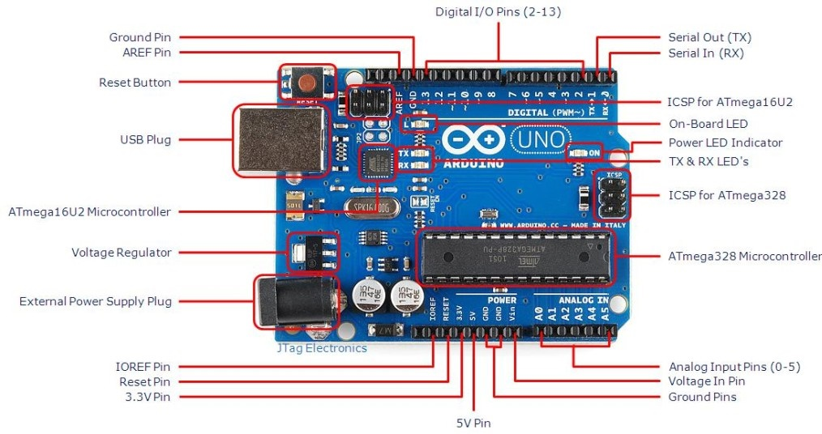

Figure 2‑1: Arduino Uno R3 Pinout Diagram.

Table 2-2: Analog pins of Arduino Uno R3.

|  |  |  |  |
| --- | --- | --- | --- |
| Pin | Function | Type | Description |
| 1 | IOREF | IOREF | Reference for digital logic V - connected to 5V |
| 2 | Reset | Reset | Reset |
| 3 | +3V3 | Power | +3V3 Power Rail |
| 4 | +5V | Power | +5V Power Rail |
| 5 | GND | Power | Ground |
| 6 | GND | Power | Ground |
| 7 | VIN | Power | Voltage Input |
| 8 | A0 | Analog/GPIO | Analog input 0 /GPIO |
| 9 | A1 | Analog/GPIO | Analog input 1 /GPIO |
| 10 | A2 | Analog/GPIO | Analog input 2 /GPIO |
| 11 | A3 | Analog/GPIO | Analog input 3 /GPIO |
| 12 | A4/SDA | Analog input/I2C | Analog input 4/I2C Data line |
| 13 | A5/SCL | Analog input/I2C | Analog input 5/I2C Clock line |

Table 2-3: Digital pins of Arduino Uno R3.

|  |  |  |  |
| --- | --- | --- | --- |
| Pin | Function | Type | Description |
| 1 | D0 | Digital/GPIO | Digital pin 0/GPIO |
| 2 | D1 | Digital/GPIO | Digital pin 1/GPIO |
| 3 | D2 | Digital/GPIO | Digital pin 2/GPIO |
| 4 | D3 | Digital/GPIO | Digital pin 3/GPIO |
| 5 | D4 | Digital/GPIO | Digital pin 4/GPIO |
| 6 | D5 | Digital/GPIO | Digital pin 5/GPIO |
| 7 | D6 | Digital/GPIO | Digital pin 6/GPIO |
| 8 | D7 | Digital/GPIO | Digital pin 7/GPIO |
| 9 | D8 | Digital/GPIO | Digital pin 8/GPIO |
| 10 | D9 | Digital/GPIO | Digital pin 9/GPIO |
| 11 | SS | Digital | SPI Chip Select |
| 12 | MOSI | Digital | SPI1 Main Out Secondary In |
| 13 | MISO | Digital | SPI Main In Secondary Out |
| 14 | SCK | Digital | SPI serial clock output |
| 15 | GND | Power | Ground |
| 16 | AREF | Digital | Analog reference voltage |
| 17 | A4/SD4 | Digital | Analog input 4/I2C Data line (duplicated) |
| 18 | A5/SD5 | Digital | Analog input 5/I2C Clock line (duplicated) |

### Board Outline & Mounting Holes

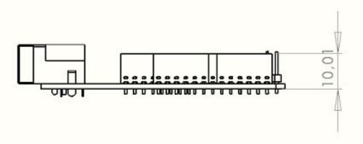

Figure 2-2: Side of the board.

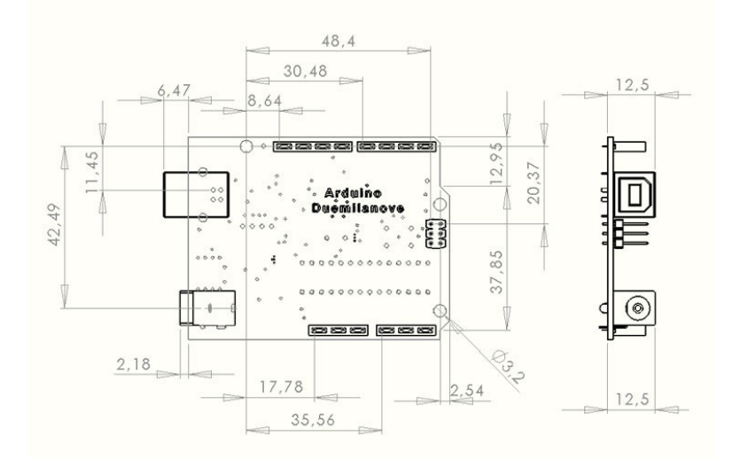

Figure 2-3: Front side of the board.

## ESP 32

### Introduction to ESP32

The ESP32 is a low-cost and low-power System-on-Chip (SoC) microcontroller developed by Espressif Systems, the manufacturer of the ESP8266 SoC. Building on the success of the ESP8266, the ESP32 comes in both single-core and dual-core variants, utilizing Tensilica's 32-bit Xtensa LX6 processor, and features integrated Wi-Fi and Bluetooth capabilities.

Espressif Systems, a Shanghai-based company in China, is responsible for the production and development of the ESP32, using TSMC's 40nm process technology. The ESP32 is considered a perfect evolution from the ESP8266, offering a high-integration Wi-Fi SoC solution to meet the growing demands in the Internet of Things (IoT) field.

With its full and stable Wi-Fi network connectivity, the ESP32 can function as a standalone application. Its quick boot process from flash memory makes it efficient. The integrated high-speed cache helps enhance system performance and optimize memory usage.

In addition to Wi-Fi functionality, the ESP32 also integrates GPIO (General Purpose Input/Output) pins allowing connections to peripheral devices and sensors. The ESP32 can interface with various devices such as LCD screens (using I2C interface), RTC (Real-Time Clock) chips, GPS modules, touch screens, SD cards, and many other devices through serial protocols like SPI, SDIO, I2C, and UART.

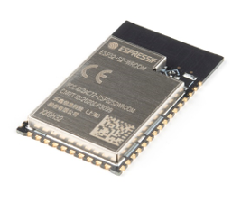

Figure 2-4: ESP32

### Technical Specifications

**CPU:**

* CPU: Xtensa Dual-Core LX6 microprocessor
* 32-bit architecture
* Chip processing speed from 160 MHz to 240 MHz
* ROM: 448 KB
* Clock speed from 40 MHz to 80 MHz (customizable when programming)
* RAM: 520 KB on-chip SRAM. Including 8KB high-speed RTC RAM – 8KB low-speed RTC RAM

**Supports 2 wireless interfaces:**

* WiFi: 802.11 b/g/n/e/i
* Bluetooth: V4.2 and BLE

**Supports all types of interfaces:**

* 28-bit Digital-to-Analog Converters (DAC)
* 18 channels of 12-bit Analog-to-Digital Converter (ADC)
* 2 I2C interfaces
* 3 UART interfaces
* 3 SPI interfaces (1 for FLASH chip)
* 10 Pulse Width Modulation (PWM) output channels
* Ethernet MAC supporting: DMA and IEEE 1588 standard
* CAN bus 2.0

**Integrated sensors on ESP32 chip:**

* 1 Hall sensor (magnetic field sensor)
* 1 temperature sensor
* Touch sensor (capacitive) with 10 different inputs

**Security:**

* Supports all IEEE 802.11 standard security features including WFA, WPA/WPA2 and WAPI
* Secure boot
* Flash encryption
* 1023-bit OTP, up to 768 bits for customers
* Hardware acceleration for cryptography: AES, SHA-2, RSA, elliptic-curve cryptography

**Operating power**

* Operating voltage: 2.2V to 3.6V
* Operating temperature: -40°C to 85°C
* Number of GPIO ports: 36

**Applications:**

* The module is widely used in data collection and device control applications via WiFi, Bluetooth.
* Used for energy-saving applications, sensor network control, encryption or voice processing, Analog-Digital processing in music playback applications, or with MP3 files...
* The module can also be used for wearable electronic devices such as smartwatches...

**ESP32 Programming Environment:**

* ESP32 can be programmed in various programming environments including Arduino IDE, Espressif IDF, Micropython, and more.

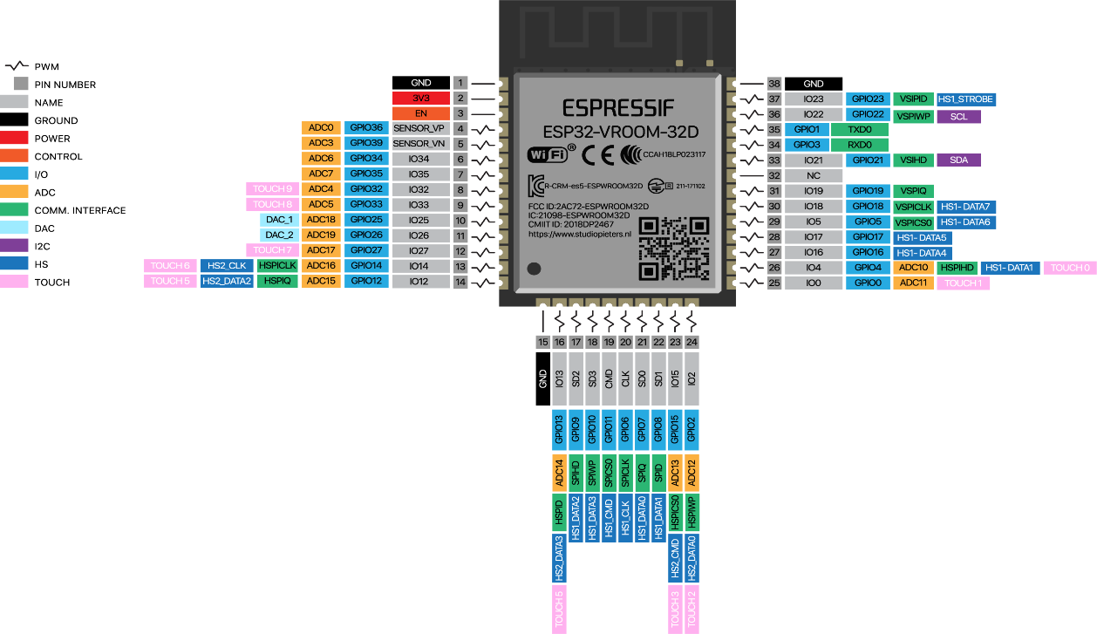

Figure 2-5: ESP32 pinout.

## Raspberry Pi 4 Model B

### General Introduction

The Raspberry Pi 4 (RPi 4) is a compact and powerful computer module developed by the Raspberry Pi Foundation. With its high processing power and multitasking capabilities, the RPi 4 has become a popular choice for various applications, ranging from embedded systems to IoT projects and motor control.

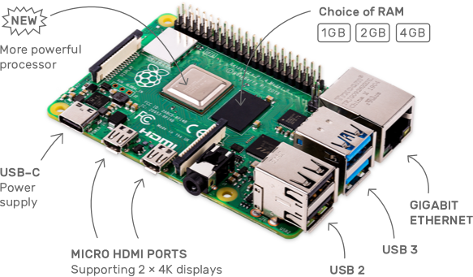

Figure 2-6: Raspberry Pi4.

### Technical specifications

Table 2-4: Technical specifications of Raspberry Pi4.

|  |  |
| --- | --- |
| Feature | Description |
| Release date | 24th June 2019 |
| SOC | Broadcom BCM2711 quad-core Cortex-A72 @ 1.5 GHz |
| GPU | VideoCore VI with OpenGL ES 1.1, 2.0, 3.0 |
| Video Decode | H.265 4Kp60, H.264 1080p60 |
| Video Encode | H.264 1080p30 |
| Memory | 4GB LPDDR4-2400 SDRAM |
| Storage | MicroSD card |
| Video & Audio Output | 2x micro HDMI ports up to 4Kp60  3.5mm AV port (composite + audio)  MIPI DSI connector |
| Camera | MIPI DSI connector |
| Ethernet | Native Gigabit Ethernet |
| WiFi | Dual band 802.11 b/g/n/ac |
| Bluetooth | Bluetooth 5.0 + BLE |
| USB | 2x USB 3.0 + 2x USB 2.0 |
| Expansion | 40-pin GPIO header |
| Power Supply | 5V via USB type-C up to 3A  5V via GPIO header up to 3A  Power over Ethernet via PoE HAT |
| Dimensions | 85×56 mm |

### Function of the ports

The Raspberry Pi 4 has 40 GPIO (General Purpose Input/Output) pins, providing flexibility in connecting to modules and speed control devices. We can use the VCC and GND pins to power devices and use the GPIO pins as control signal pins.

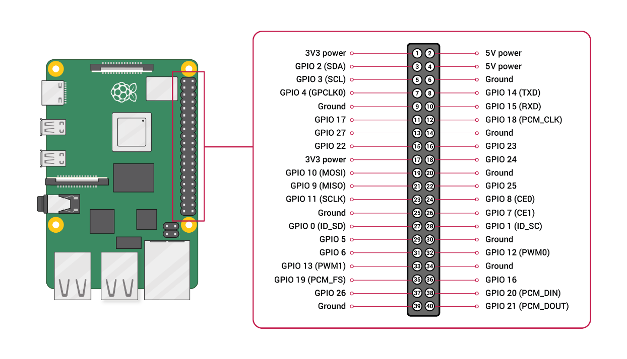

Figure 2-7: Function of the ports of Raspberry Pi4.

### Application of Raspberry Pi 4

In this study, the Raspberry Pi 4 plays a critical role as the central processing unit responsible for managing several key functions of the robotic arm system. The specific applications of the Raspberry Pi 4 include:

* **Image Acquisition and Processing:**

- The Raspberry Pi 4 captures images of the products using a connected camera module.

- It processes these images to identify and classify the products based on their shape and color using advanced image processing algorithms.

* **Data Processing and Analysis:**

- The Raspberry Pi 4 analyzes the processed image data to determine the appropriate sorting actions.

- It interprets the data to generate commands for the robotic arm and conveyor belt system.

* **Control Integration:**

- The Raspberry Pi 4 communicates with the Arduino Uno R3 to send control signals for the robotic arm's movements.

- It ensures synchronization between the image processing results and the robotic arm’s actions.

* **Conveyor Belt Management:**

- The Raspberry Pi 4 interfaces with the ESP32 to control the conveyor belt’s operation, ensuring it starts and stops at the right times based on the presence of products detected by infrared sensors.

* **Web Interface Communication:**

- The Raspberry Pi 4 facilitates real-time data exchange with the web interface developed using Node-RED and MQTT.

- It provides status updates, operational controls, and system monitoring capabilities to users through the web interface.

* **System Monitoring and Diagnostics:**

- The Raspberry Pi 4 continuously monitors the system’s performance and operational status.

- It runs diagnostics to detect and troubleshoot any issues, ensuring reliable and efficient operation.

By leveraging the versatile capabilities of the Raspberry Pi 4, the study aims to create an integrated and intelligent robotic arm system that efficiently automates the sorting of products by shape and color, thereby enhancing productivity and accuracy in industrial applications.

## Driver A4988

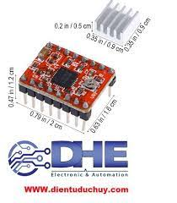

Figure 2-8: Image of A4988 control circuit.

Table 2-5: Technical specifications of Driver A4988.

|  |  |
| --- | --- |
| Feature | Description |
| Model | HR4988 Stepper Motor Driver. |
| Output capacity | 35V |
| Max current | 2A |
| Current limit | VREF × 2.5 |

* **Function of ports:**

Table 2-6: Function of ports of Driver A4988.

|  |  |
| --- | --- |
| Feature | Description |
| EN (Enable Pin) | * High signal: Enables motor operation. * Low signal: Disables motor operation. |
| MS1, MS2, MS3 | Sets the microstepping mode for the motor. |
| RST (Reset Pin) | * Puts the circuit into sleep mode and pauses the motor when the signal is high. * Resumes motor operation when the signal is low. |
| SLP (Sleep Pin) | The motor pauses when it is at a high logic level and vice versa when the motor is at a low logic level. |
| STEP (Step Pin) | Generates pulses to control the motor's speed. |
| DIR (Direction Pin) | Determines the direction and coordinates for the motor's movement. |
| VMOT | Provides power to the motor for operation. (8-35V) |
| 1B, 2A, 1A, 2B | Enables communication between the control circuit and the motor. |
| VDD | Provides power to the control circuit for operation. (3-5.5V) |
| GND | Provides a ground connection for the circuit. |

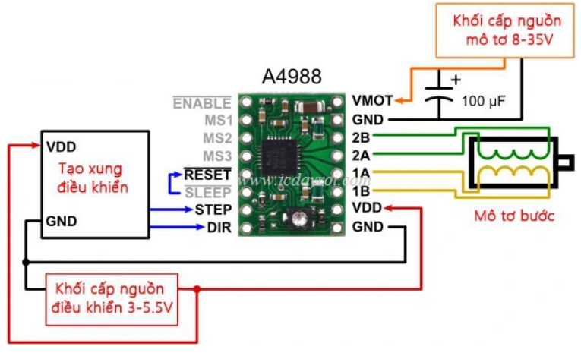

Figure 2-9: Wiring diagram of circuit A4988.

|  |  |  |  |
| --- | --- | --- | --- |
| MS1 | MS2 | MS3 | Microstep Resolution |
| L | L | L | Full Step |
| H | L | L | Half Step |
| L | H | L | 1/4 Step |
| H | H | L | 1/8 Step |
| H | H | H | 1/16 Step |

Table 2-7: Sets the microstepping mode for the motor.

## Nema 17 Stepper Motor Usongshine 17HS4401

Stepper motor with a 42mm frame size, belonging to the Nema 17 category. The Usongshine 17HS4401 is a premium stepper motor with a robust copper wire coil for exceptional durability and stability. It exhibits minimal heat production and has an imported epoxy-coated motor core to decrease wear and tear over extended periods of operation. This motor is particularly well-suited for constructing uncomplicated mechanical models and 3D printers.

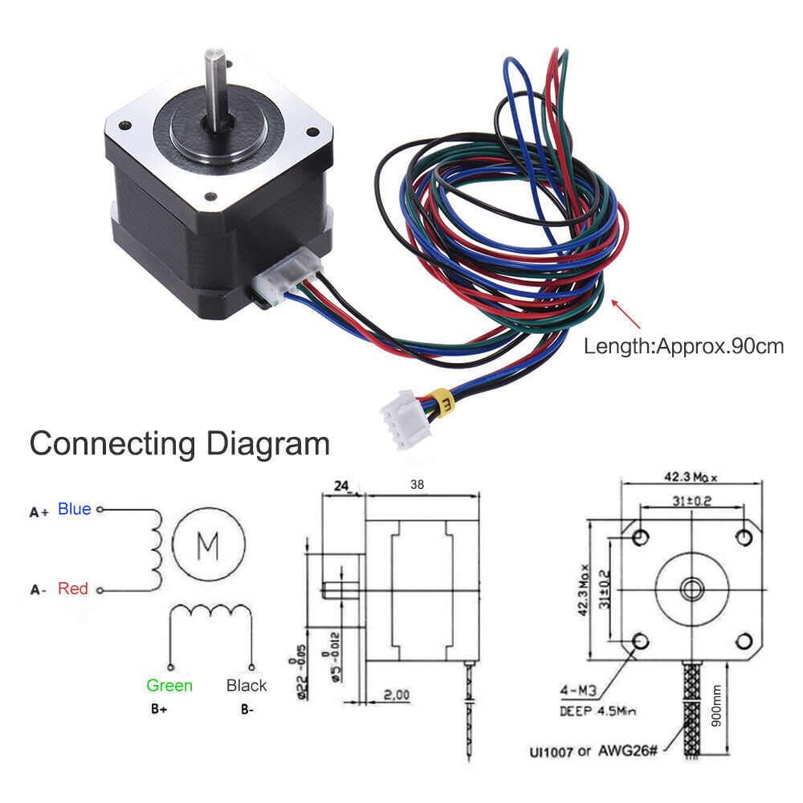

Figure 2-10: Stepper motor 17HS4401S.

Table 2-8: Technical specifications of Stepper motor 17HS4401S.

|  |  |
| --- | --- |
| Feature | Description |
| Weight | 280g |
| Body length | 40mm |
| Axle length | 23mm |
| Frame size | 42x42mm |
| Step angle accuracy | ± 5% (full step, no load) |
| Inertial Rotor | 54g.cm2 |
| Torque | 2,2N.cm |
| Momet torque holder | 40N.cm |
| Current | 1,7A |
| Stepping angle | 1.8° ( 200 steps / rotation) |



Figure 2-11: Stepper motor 17HS4401S figure.

## CNC Shield V3

CNC Shield V3 is an extension board for Arduino, designed to control step engines in CNC projects, 3D printers and laser engravers. The board supports four axes (X, Y, Z, A) and step engine control modules such as the A4988 or DRV8825. CNC Shield V3 provides connector ports for travel switches, engine control axles, and 12V or 24V power supply, making setup and configuration simple and convenient. This is an effective solution for precision control and automation applications.

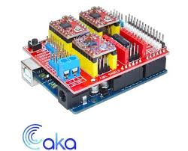

Figure 2-12: CNC Shield V3.

Table 2-9: Technical specifications of CNC Shield V3.

|  |  |
| --- | --- |
| Feature | Description |
| Compatibility | Compatible with Arduino Uno R3 |
| Axis control | Support for 4 axes: X, Y, Z, A  Axis A can be configured to duplicate axis X, Y or Z |
| Jumper and configuration | Jumper to configure microscope and other functions The jumper to select the logical voltage 3.3V or 5V |
| Power | 12 to 36V |
| Step Engine Control Module | A4988 và DRV8825 |
| Scalability | Slots for extended modules and other sensors |

## Power source

The 12V power supply is a popular switching power supply, designed to supply a 12V DC stable voltage to electronic devices. The source has great advantages in high performance, compact, long life, low heat radiation. With a good heat dissipation net design, the 12V beehive source typically has the following characteristics:

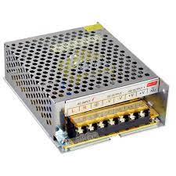

Figure 2-13: Power source 12VDC.

Table 2-10: Technical specifications of power source.

|  |  |
| --- | --- |
| Feature | Description |
| Input Voltage | 110/220VAC |
| Current | 20A |
| Output Voltages | 12VDC |
| Working temperature | About 0 to 60 degree |
| Dimensions | 198 x 98 x 42mm. |
| Maximum current | 5A |
| Power | 60W |

## Limit switch KW11-3Z

A limit switch is an electromechanical device that detects the position or movement limit of a mechanical part. When the component moves to the limit point, the switch is activated, sending a disconnect signal or changing the status.

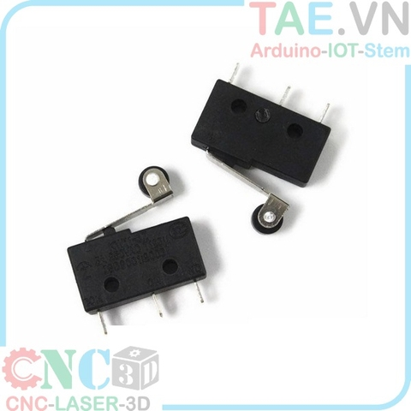

Figure 2-14: Limit switch KW11-3Z.

Table 2-11: Technical specifications of limit switch.

|  |  |
| --- | --- |
| Feature | Description |
| Dimensions | 20mm x 6.4mm x 10mm |
| Operating voltage | 250V AC |
| Standard current | 5A |
| Contact configuration | 1NO + 1NC |
| Mechanical lifetime | Activated: More than 1,000,000 times |
| Power required to trigger | About 0.98N (100gf) |
| Contact material | Silver or silver alloy |

## Module relay 5V

The 5V relay module is an electronic switch that is controlled by 5V voltage signals from microcontroller like Arduino, Raspberry Pi. It allows you to control high voltage loads or large current using low voltage signals. Due to the built-in module, additional functions are extended, such as isolation with all microcontroller thanks to IC and transistor.

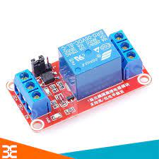

Figure 2-15: Module relay 5V.

Table 2-12: Technical specifications of Module relay 5V.

|  |  |
| --- | --- |
| Feature | Description |
| Maximum voltage | 250V |
| Control voltage | 5V |
| Current for relays | 5mA |
| Weight | 15g |
| Dimensions | 43mm x 17.3mm x 17mm |

Table 2-13: Function pins of Module relay 5V.

|  |  |
| --- | --- |
| Feature | Description |
| NO | Normally Open |
| NC | Normally Closed |
| COM | Common leg |
| VCC | 5V Power |
| GND | Ground |
| In | Digital Pin |

## Webcam Q-2O

The Q-2O Webcam is a handy computer camera device, designed to meet basic online communication and working needs. With standard VGA resolution, this webcam delivers enough image quality for video calls and online conferences.

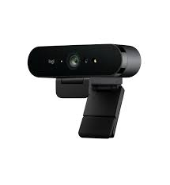

Figure 2-16: Webcam Q-2O.

Table 2-14: Technical specifications of Webcam Q-2O.

|  |  |
| --- | --- |
| Feature | Description |
| Resolution | 1920x1080 pixels |
| Connection Interface | USB 2.0 |
| Frame Rate | 30 fps (frames per second) at maximum resolution |
| Lens | * Fixed focus * 60-70 degree field of view |
| Integrated Microphone | Single microphone built into the webcam |
| Operating System Compatibility | Windows, Mac OS, Linux |
| Cable Length | Approximately 1.5 meters |

## Mini Vacuum Pump Brushless Motor

The Kamoer KVP8-KD-S vacuum pump engine is a dedicated device designed to generate vacuum and move liquids or gases.

The Kamoer KVP8-KD-S Air Foot Pump Engine is a mini vacuum pump using a coal-brush-free engine, which is compact in size, high performance and low noise.

With stable operation and high efficiency, the Kamoer KVP8-KD-S is the ideal choice for a wide range of applications in medical, industrial, laboratory and many other industries.

* **Advantages:**
* Small and lightweight
* High performance
* Low noise
* Dry running (no oil required)
* Longevity
* Easy to use and maintain
* **Disadvantages:**
* Vacuum pressure is lower than some other pumps
* Lower gas flow than some other pumps

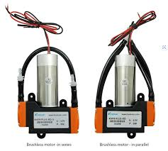

Figure 2-17: KVP8-KD-S vacuum pump.

Table 2-15: Technical specifications of KVP8-KD-S vacuum pump.

|  |  |
| --- | --- |
| Feature | Description |
| Power | 8W |
| Rated Voltage | 12V |
| Flow | >=8L/min |
| Negative pressure | <=0.06Mpa |
| Positive pressure | >=0.1Mpa |
| Noise | <=65dB |
| Product life | >=2000h |
| Weight | 240g |
| Working temperature | About 0 to 50 degree |

## Solidworks

Solidworks is a specialized 3D design software for engineering and mechanics, standing out alongside AutoCAD. Unlike AutoCAD, which excels in 2D design, Solidworks is superior in 3D modeling. Released in 1995 by Solidworks Dassault Systemes (France), it now has over six million users and more than 200 companies utilizing it. The features of Solidworks include:

* 3D Model Design: Easily and accurately build models quickly. It can easily and quickly convert 3D drawings to 2D.
* Assembly Design: You can draw individual parts of a design and assemble them easily.
* Drawing Export: Automatically provides precise dimensioning tools. Additionally, it includes features for indicating surface roughness, dimensional and geometric tolerances.
* Tab and Slot Feature: Allows users to assemble welded parts using the Tab feature.
* Dynamic Analysis: Enables users to simulate and check, improving the quality of the design. It keeps users informed about connections, static relations, dimensions, and materials during the design process.



Figure 2-18: Solidworks software.

## Arduino

Arduino is an open-source electronics platform that is used to build and program microcontrollers. The software was first released in 2005 as a student project at the Interaction Design Institute Ivrea (Italy) for the purpose of teaching and research. The key features of the software are as follows:

* Open-source: Arduino is free to use, making it accessible to individuals, businesses, and schools for learning and research.
* Supports a wide range of microcontrollers: Arduino supports a wide range of microcontrollers, as well as a rich library of components, which makes it easy to build and prototype projects quickly.
* User-friendly interface: Arduino has a user-friendly interface that is easy to learn and use, even for beginners.
* Cross-platform: Arduino can be used on a variety of operating systems, including Windows, macOS, and Linux.



Figure 2-19: Arduino software.

## Visual Studio Code

Visual Studio Code (VS Code) is an open source editor developed by Microsoft. This is a powerful and versatile tool, widely used by software developers. Here are some of the highlights of Visual Studio Code:

1. User interface

* Simple and easy to use: Intuitive interface, easy to customize with different themes and layouts.
* Mini Map: Allows you to view the entire source code in a miniature view at the right of the edit window.

2. Multilingual programming support

* Programming languages: Supports many languages such as JavaScript, TypeScript, Python, C++, C#, Java, Go, and many more.

3. Extensions

* Thousands of extensions are available on the Visual Studio Code Marketplace, expanding the capabilities of the editor to suit your needs.

4. IntelliSense development features

* Intelligent code suggestions, automatic code completion and information on functions and variables.
* Debugging: Powerful debugging tool with breakpoint support, code pass, and variable value tracking.
* Integrated Terminal: Allows you to run shell commands right in the editor without switching windows.

5. Performance and multi-platform

* Easy and fast: Good performance even when dealing with large projects.
* Multi-platform: Supports Windows, macOS, and Linux.

In short, Visual Studio Code is a powerful, versatile and easy-to-use open-source editor with many features that support effective software development. It is a popular choice by developers thanks to its high customizability and strong support community.



Figure 2-20: Visual Studio Code.

## UART Communication

UART, or Universal Asynchronous Receiver/Transmitter, is a device-to-device communication protocol based on a non-synchronized basis. (asynchronous). It uses two main wires, TX (Transmit) and RX (Receive) to transmit and receive data. Non-synchronized UART communication means there is no common clock signal between the transmitter and the receiver. Instead, it uses data frames with some data bits, test bits and control bits.

Basic Parameters in UART Communication:

Table 2-16: Parameters in UART.

|  |  |
| --- | --- |
| Feature | Description |
| Baud Rate | This is the number of bits of data transmitted or received per second. The unit is bits per second. (bps). Baud rate needs to be configured in the same way between transmitters and receivers to ensure accurate communication. |
| Data Bits | Data Bits is the number of data bits transmitted in each data frame. Typically, the common values are 7 or 8 bits. |
| Parity | Sometimes used to check for errors in data transmission. It can be none, odd, or even. |
| Stop Bits | It's a stick that's added at the end of each frame to make sure the receiver has enough time to prepare for the next frame. Usually one stop bit is used, but it can also be 2 bits. |

* **Application:**

Table 2-17: Application of UART.

|  |  |
| --- | --- |
| Feature | Description |
| Device Connection | UARTs are commonly used to connect devices such as microprocessors, sensors, communication modules, and many other electromagnetic devices.  UART is commonly used in programming and debugging to transmit information between a computer and peripheral devices. |
| Data Transfer | Applications such as data transfer between computer and microcontroller, sensors, GPS modules often use UART communication. |
| IoT and Sensational Networks | In IoT applications and sensor networks, UART is commonly used to connect and transmit data between network nodes. |
| Control Panel and Communication Module | In projects like the dashboard, the UART communication module is often integrated to interact and control different devices. |

## MQTT

MQTT, which stands for Message Queuing Telemetry Transport, is a publish/subscribe-based messaging protocol that facilitates asynchronous communication between remote devices over low-bandwidth networks. Widely utilized in IoT applications, MQTT ensures high reliability, making it suitable for unstable and bandwidth-constrained networks.

* **Core Components:**
* Broker: The central component, responsible for storing and distributing messages.
* Clients: Devices and applications that connect to the broker and interact via MQTT packets adhering to the OASIS standard.
* **Origins and Evolution:**

Initially developed by IBM as a lightweight and reliable protocol for machine-to-machine (M2M) communication, MQTT has evolved into an integral part of embedded systems, particularly in IoT projects, due to its compelling advantages.

* **Advantages:**
* Low-Cost: MQTT is a cost-effective protocol, catering to bandwidth constraints.
* Embedded Device Friendly: Designed for embedded M2M communication, MQTT offers an efficient and reliable packet delivery mechanism, suitable for devices with limited memory.
* Wireless Network Optimization: It is a prime choice for wireless networks facing bandwidth fluctuations and unreliable connectivity.
* **Applications:**
* Resource-Constrained Environments: Where network data plans are expensive or bandwidth is low and unreliable.
* Embedded Devices: When operating on embedded devices with limited processing power and memory resources.
* M2M Applications: Aiming to minimize energy consumption and reduce bandwidth usage in high-latency environments, MQTT is a top choice for M2M applications.
* **MQTT Publish/Subscribe Model**

MQTT Broker serves as the central hub of the Publish/Subscribe protocol, analogous to a relay station for all connections from message-sending Clients and Clients subscribing to receive those messages. Pictorially, MQTT can be likened to a postal system, where all mail and parcels must pass through the post office before reaching the intended recipient.

The primary functions of an MQTT Broker include:

1. Receiving messages from publishing Clients.
2. Queuing messages for efficient delivery.
3. Routing messages to the appropriate destinations based on subscribed Topics.
4. Handling millions of concurrent MQTT connections.

When selecting an MQTT Broker, businesses should evaluate the protocol's scalability, integration, monitoring, and fault tolerance capabilities.

MQTT Clients represent hardware devices or applications capable of interacting with the MQTT Broker to transmit and receive data. An MQTT Client can be a small sensor providing data at fixed intervals or a computer application that displays sensor data.

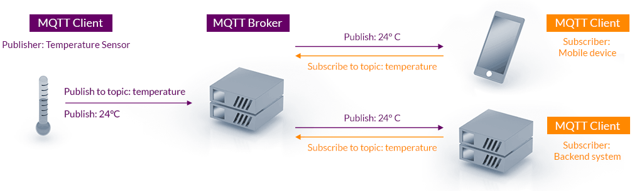

Figure 2-21: Operational model of components in MQTT.

* **MQTT Clients are categorized into two roles:**

1. Publisher: Sends messages to the Broker.
2. Subscriber: Receives messages from the Broker.

Topics act as logical channels between Publishers and Subscribers. Each MQTT Client communicates data through Topics managed by the Broker. When a Client subscribes to receive data, the Broker directs messages from publishing Clients to the corresponding Subscribers. Clients can subscribe to and publish to multiple Topics.

* **Key Points:**
* MQTT Broker: Central hub for message routing and delivery.
* MQTT Clients: Devices or applications that publish or subscribe to messages.
* Topics: Logical channels for message transmission and reception.
* Publisher: Sends messages to Topics.
* Subscriber: Receives messages from Topics.
* **Benefits of MQTT Publish/Subscribe Model:**
* Decoupled Communication: Clients communicate indirectly through the Broker, reducing complexity and improving scalability.
* Efficient Data Delivery: Messages are routed directly to interested Subscribers, minimizing unnecessary data transmission.
* Reliable Message Delivery: MQTT offers multiple delivery mechanisms, ensuring messages reach their intended recipients.
* Scalability: The protocol can handle a large number of concurrent connections and messages.
* Low Bandwidth Consumption: MQTT is designed for resource-constrained environments, minimizing bandwidth usage.

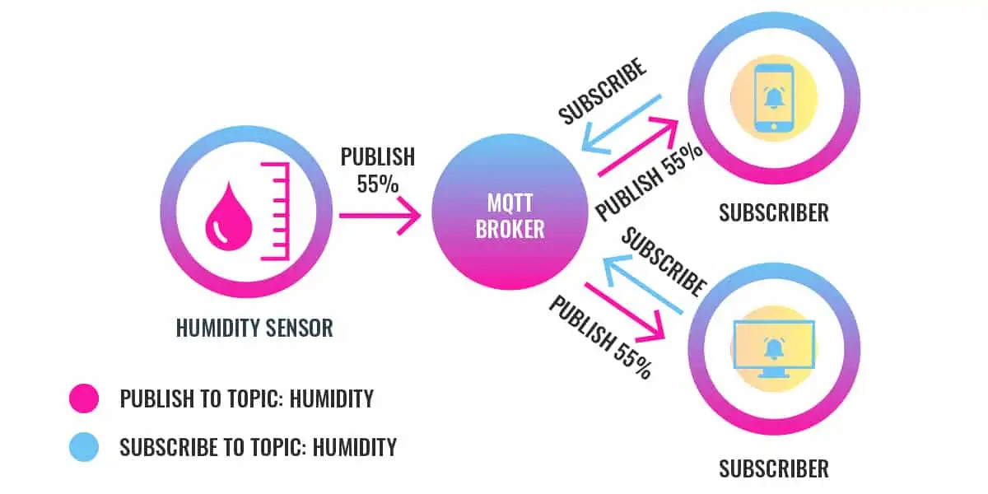

Figure 2-22: MQTT publish/subscribe operating model.

## Node red

Node-RED is an open-source, flow-based programming tool used to connect hardware devices, APIs (Application Programming Interfaces), and online services in new ways. It is especially suitable for applications in the field of Internet of Things (IoT).

Below is an analysis of the fundamental attributes of Node-RED:

* Node-RED offers a browser-based editor that enables you to develop programs by simply dragging and dropping nodes, instead of manually inputting lines of code. This feature enables people with diverse programming backgrounds to easily access it.
* Flow-Based Development involves the construction of applications through the creation of flows that connect various nodes. Every node corresponds to a distinct function, such as transmitting data, analyzing information, or engaging with an API.
* Node-RED offers a diverse range of pre-existing nodes that cover various activities such as sending emails, retrieving sensor data, and managing hardware devices. Furthermore, you have the option to install supplementary nodes from the community in order to enhance its usefulness.
* Effortless Deployment: Node-RED allows for the swift deployment of flows with a single click, simplifying the task of launching your application.
* Node-RED allows for the integration of JavaScript code within nodes to handle more intricate jobs, in addition to its visual approach.



Figure 2-23: Node-red.

* **Advantages of Utilizing Node-RED:**
* Rapid prototyping is facilitated by the use of a visual interface and pre-built nodes, allowing for efficient development and testing of IoT applications.
* Reduced Threshold: The visual interface of Node-RED makes it accessible to novices and individuals with minimal programming expertise.
* Flexibility: The wide range of nodes available in the library, along with the option to include custom nodes, effectively meet the requirements of various IoT applications.
* Node-RED is highly proficient in managing real-time data flows from connected devices and services.

Node-RED is an immensely potent technology that streamlines the process of creating IoT apps. Due to its visual programming method, extensive node library, and user-friendly interface, it is widely favored by both novice and proficient programmers.

## Robot

### Concept

A robot is a term that characterizes a mechanical agent, a device capable of performing tasks automatically under the control of a computer or programmed electronic circuits. Designed to replace or assist human work, robots can perform various tasks ranging from simple to complex.

Robots often appear as electro-mechanical agents, and the flexible combination of sensors, computers, and control programs allows them to adapt to their surroundings. This creates an impression for observers of their human-like interaction with the environment.

The term "robot" is generally understood in two aspects: mechanical robots and automated software robots. In the field of robotics, the United States and Japan play significant roles and are pioneering countries in robotics research and development. These two nations not only produce advanced mechanical devices but also focus on developing software to enhance the automation and interaction capabilities of robots.

Moreover, the concept of robots is also related to many fields such as artificial intelligence, machine learning, and automation. The development of robots not only opens up numerous opportunities in industry and services but also poses new challenges related to ethics, information security, and the future of labor.

### Functions of Robots

Robots, advanced technological and automated machines, are programmed by computers to perform complex actions. Their structure is diverse and flexible, controlled by devices such as linear guides, ball screws, motors, wheels, and tracks. Most robots focus on function and performance rather than aesthetics.

Key functions include replacing arduous, dangerous, or repetitive labor, automating production processes to enhance productivity and product quality, and assisting in medical fields like precision surgery. They operate in hazardous environments, such as space and deep oceans, with the Curiosity rover on Mars being a prime example.

Robots also enter daily life, providing entertainment, companionship, and support in military and security tasks. They play roles in education and everyday tasks like cleaning and cooking. Continuous advancements in robotics open new possibilities, making them reliable partners and an integral part of modern life.

### Degrees of Freedom of a Robot Arm

Degrees of freedom refer to the number of movement capabilities of a mechanism to position an object in space. The actuator mechanism of a robot must achieve a certain number of degrees of freedom. Generally, the system of a robot is an open mechanism (a mechanism with one fixed link).

The movement of the links in a robot is usually one of the two basic types of movement: translation or rotation.

The number of degrees of freedom of a robot is determined by:

$$W=6n-\sum{iP_{i}}$$

*Where:*

* *W: Number of degrees of freedom of the robot.*
* *n: Number of moving links.*
* *Pi​: Number of joints of type i.*
* *A joint of type i is a joint that constrains i degrees of freedom.*

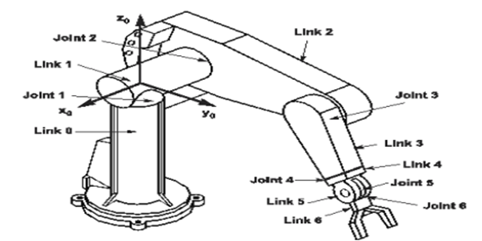

Figure 2-24: Robotic arm with 6 degrees of freedom.

### Coordinate System

Each robot typically consists of multiple links connected through joints, forming a kinematic chain starting from a fixed base link. The coordinate system attached to the base link is called the basic coordinate system (or reference coordinate system).

Other intermediate coordinate systems attached to the moving links are called extended coordinate systems. At each moment of operation, the extended coordinates determine the configuration of the robot through linear displacements or angular displacements of the prismatic or revolute joints. The remaining extended coordinates are the joint variables.

All coordinate systems used in robots must adhere to the right-hand rule: Using the right hand, fold the little finger and ring finger, point the thumb along the z-axis, the index finger along the x-axis, and the middle finger along the y-axis.

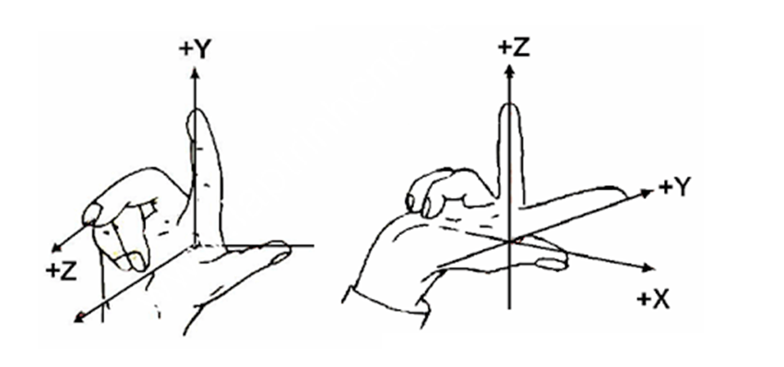

Figure 2-25: Right hand rule.

### Forward Kinematics

Forward kinematics is used to calculate the positions and orientations of a robot's joints when given specific values. The process for solving forward kinematics problems is as follows:

1. Identify and assign coordinate systems to the links.

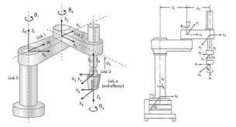

Figure 2-27: Coordinate system attached to the robot.

1. Determine the Denavit-Hartenberg (DH) parameters.
2. From the DH parameters, determine the transformation matrix ​ .

The frame transformation  describe the finite motion from link *i-1* to link *i* can be expressed as the following sequence:

* : Defined as a single rotation by angle  around the -axis.
* : Defined as a translation by distance  along the -axis.
* : Defined as a single rotation by angle  around the -axis.
* : Defined as a translation by distance  along the -axis.

The homogeneous transformation  is represented as a product of four basic transformation as follows:





1. From the above matrix, we continue to find the transformation matrix.



### Inverse Kinematics

Inverse kinematics allows us to determine the forces or drive moments of the driving links from the motion laws of the operation links of the Robot.

The characteristics are that there is no general method, and the solution is not unique. The conditions for the existence of a solution to the problem are as follows: the position and direction lie within the Robot's workspace. However, it is necessary to clearly distinguish between two types of solutions: mathematical solutions and physical solutions. Regarding mathematical solutions, the solution satisfies the equation's conditions, and the physical solution lies within the limits of joints, links, etc., collectively referred to as physical limits.

Additionally, the inverse kinematics problem can be divided into two smaller problems of position and orientation as follows: inverse position kinematics and inverse orientation kinematics, which become independent problems. This allows for easier computation with fewer parameters than the original problem.

There are two main methods to solve the inverse kinematics problem: closed-form solutions and numerical solutions.

Closed-form solutions are widely used due to their finite expressions and analytic operations. Within this method, there are two sub-branches: algebraic methods and geometric methods.

* Algebraic methods: a subset of closed-form solutions using finite algebraic expressions.
* Geometric methods: another subset of closed-form solutions utilizing geometric properties.

Numerical methods involve iterative and computational approaches.

1. CALCULATION AND DESIGN

## System overview

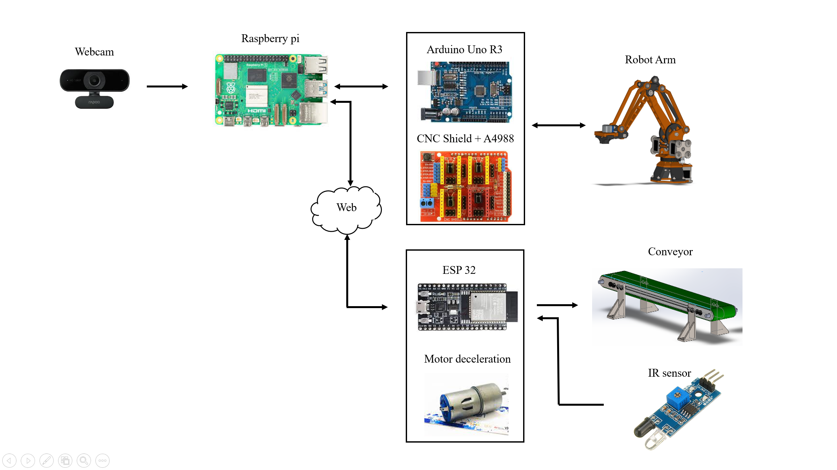

Figure 3-1:System overview.

1. **System Startup:**

* Upon system startup, the conveyor belt is activated, transporting the item to the camera's position.
* Infrared sensors connected to the Urduino monitor the item on the conveyor belt to ensure it is correctly positioned for processing.

1. **Image Acquisition:**

* The item is placed on the conveyor belt and moves to the camera's position.
* The camera captures an image of the item and sends the image data to the Raspberry Pi 4 for processing.

1. **Image Processing:**

* The Raspberry Pi 4 analyzes and processes the image to identify the color and shape of the item.
* After processing, the Raspberry Pi 4 determines the coordinate position of the item on the conveyor belt.

1. **Sending Control Signals:**

* The Raspberry Pi 4 sends the calculated values to the Arduino Uno R3 to control the robotic arm.
* The Arduino Uno R3 receives the control information and transmits signals to the motors controlling the robot's joints through the A4988 stepper motor drivers and CNC Shield V3.

1. **Conveyor Belt Control:**

* The ESP32 controls the conveyor belt based on information from the infrared sensors, ensuring the belt starts and stops at the right time to maintain process continuity.

1. **Item Manipulation:**

* The robotic arm performs the necessary movements to classify the item based on the identification results from the Raspberry Pi 4.
* The robot moves and places the item in the corresponding sorting position based on color and shape.

1. **Monitoring and Control:**

* A web interface developed using Node-RED and MQTT allows users to monitor and control the system.
* Users can start, stop, and track the robot's operating status as well as the number of items sorted.

## Robot control

In the topic of using 3d printing technology to create a robot arm. The robot arm will have 3 steps, using stepper motors. The expected size of the robot's axes is 120mm, allowing a maximum reach of 300mm. The robot's product gripper mechanism uses a vacuum suction and a vacuum motor. The robot's axes are 3d printed, but at the joints, mini bearings will be designed to help the robot's movements become smoother.

### Step motor control

The step motors will use the A4988 driver control circuit to receive signals from Arduino to control the motor. In the scope of the topic, 3 stepper motors and 3 A4988 driver motor control circuits will be used in combination with the CNC shield V3 expansion module.



Figure 3-2: Wiring diagram of circuit A4988.

The step motor used in the project is a common type, the group chose to use a Nema 17 42x42mm stepper motor. The control wires include 4 wires belonging to 2 coils in the motor. Each coil in the motor will have 2 wires connected to the control circuit in turn 1A 1B and 2A 2B, the power supply for the motor control circuit and the motor is 12v supplied by the power block.

The step angle is defined as the rotation angle of the motor when given 1 pulse. The position of the motor is determined by the step angle. The smoothness or step angle is the number of steps per revolution of the rotor (the smaller the step angle, the smoother it is). In the topic of using the Nema17 stepper motor with a step angle of 1.8 degrees, to rotate the Robot arm 360 degrees, we need to give the stepper motor 200 steps per turn of the wire.

### Pulse Supply for the Motor

The drive assembly of rotary joint 1 is controlled by stepper motor 1 with a gear ratio:

$$Gearratiol1= \frac{90}{20}=4.5$$

The drive assembly of rotary joint 2 is controlled by stepper motor 2 with a gear ratio:

$$Gearratiol2= \frac{90}{20}=4.5$$

The drive assembly of rotary joint 3 is controlled by stepper motor 3 with a gear ratio:

$$Gearratiol3= \frac{90}{20}=4.5$$

Choosing the A4988 step configuration as full step, the control pulse rotation angle is found to be:

$$Pulse=Gearratio.\frac{360}{1.8}\frac{θ}{360}$$

Setting the rotation angles of the control pulses for rotary joints 1, 2, 3 as $θ_{1}, θ_{2}, θ_{3}$, to the new rotation angles $θ_{\#1}, θ_{\#2}, θ_{\#3}$:

$$Pulse1=Gearratio1.\frac{360}{1.8}\frac{(θ_{\#1}-θ_{1})}{360}=2.5*∆ θ_{1}$$

$$Pulse2=Gearratio2.\frac{360}{1.8}\frac{(θ_{\#2}-θ_{2})}{360}=2.5*∆ θ_{2}$$

$$Pulse3=Gearratio3.\frac{360}{1.8}\frac{(θ_{\#3}-θ_{3})}{360}=2.5*∆ θ_{3}$$

## Image processing

### OpenCV library

OpenCV (Open Source Computer Vision Library) is an open-source software library designed for computer vision and machine learning. It was initially developed by Intel and later supported by Willow Garage and Itseez. OpenCV is widely used in both academia and industry due to its extensive functionality and ease of use. OpenCV is primarily written in C++ but also provides bindings for Python, Java, and MATLAB/Octave, making it accessible to a broad audience. OpenCV supports multiple operating systems, including Windows, Linux, macOS, Android, and iOS.

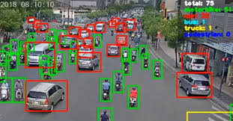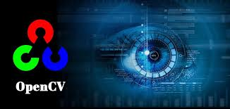

Figure 3-3: Example of image processing.

### Object identification

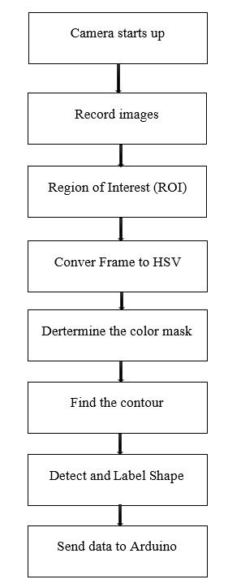

Figure 3-4: Block diagram of image processing.

### *Region of Interest (ROI)*

A Region of Interest (ROI) refers to a specific subset of an image or video frame that is chosen for the purpose of analysis. The idea of ROI, or Region of Interest, is crucial in image processing and computer vision as it enables the concentration of efforts on certain portions of an image where important information is likely to be located. This approach optimizes the chores of processing and analyzing the picture.

The Region of Interest (ROI) approach utilizes varying compression rates to encode the region of interest separately from the other areas. When adopting ROI, the picture quality in that specific region is improved in comparison to the other areas. In this scenario, the pixels inside the region of interest (ROI) are assigned a value of 1, whereas in other regions, they are assigned a value of 0.

Perform initial image processing by converting the grayscale picture into a binary image. Then, proceed to compare the threshold values in the following manner: If the pixel value in image (2) exceeds the pixel value in image (1), set it to 255 (representing white). Otherwise, set it to 0 (representing black).

The idea of Region of Interest (ROI) is a potent tool in image processing and computer vision, enabling targeted and efficient examination of specified regions within an image. Through the process of isolating and evaluating Regions of Interest (ROIs), applications in many fields may get enhanced precision and effectiveness, resulting in improved performance and results. [2]

### Color processing

Color processing is an essential field within image processing and computer vision that focuses on the modification and analysis of color data in digital pictures and movies. Color processing methods allow for a range of uses, including improving picture quality and aiding in object detection and scene comprehension. [4]

* **Basics of Color Representation**

1. Color Spaces:

* RGB: The most common color space, representing colors through the combination of Red, Green, and Blue channels.
* HSV/HSI: Stands for Hue, Saturation, and Value (or Intensity), useful for color-based segmentation and detection.
* YUV/YIQ: Separates luminance (Y) from chrominance (U and V or I and Q), beneficial for compression and transmission.

1. Color Models:

* Different color models cater to various applications. For instance, the CMYK model is used in printing, whereas the LAB model is used in color correction.

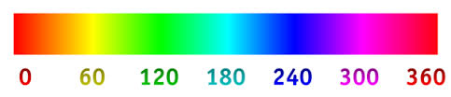

Figure 3-5: H color range in the HSV color system.

* **Basic steps**

1. Color space conversion:

* By default, images are read in RGB color space. However, HSV space is more commonly used in color classification because it separates color information (Hue) from intensity information (Value).
* Convert from RGB to HSV

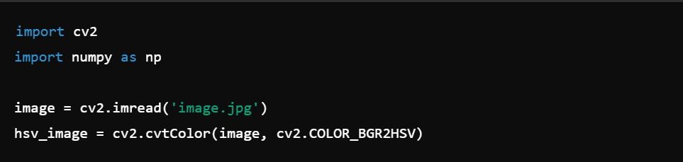

1. Color range definition:

* Determine the range of color values in HSV space that you want to classify. This includes defining the lower and upper limits of the color.
* For example: To classify the color red:

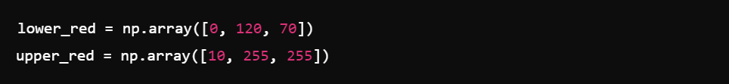

1. Create color mask:

* Use the defined color range to create a mask containing only pixels whose color falls within that range.
* Create a mask:



1. Apply the mask to the original image:

* Apply a mask to extract colored areas from the original image.
* Apply the mask:



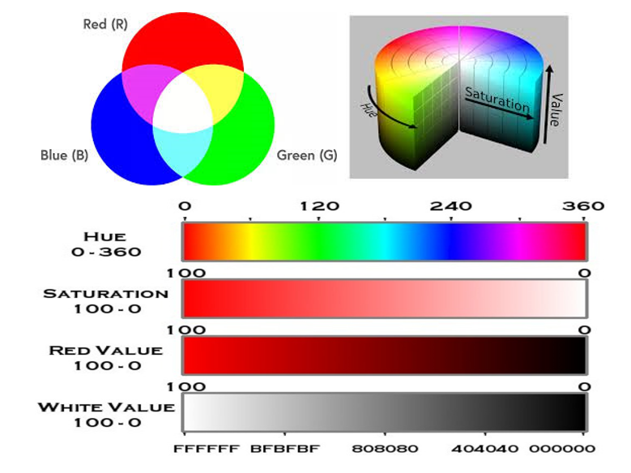

Figure 3-6: Color model.

5) The cv2.approxPolyDP function is used to speed up a contour or curve by one less polygon, but keeping the same basic shape.

* Calculate the perimeter of a contour or the length of a curve.



* Contour approximation, using the Ramer–Douglas–Peucker (RDP) algorithm, aims to simplify a polyline by reducing its vertices for a threshold value. In simple terms, we take a curve and reduce the number of its vertices while keeping most of its shape intact.



* **Result of contour approximation function**

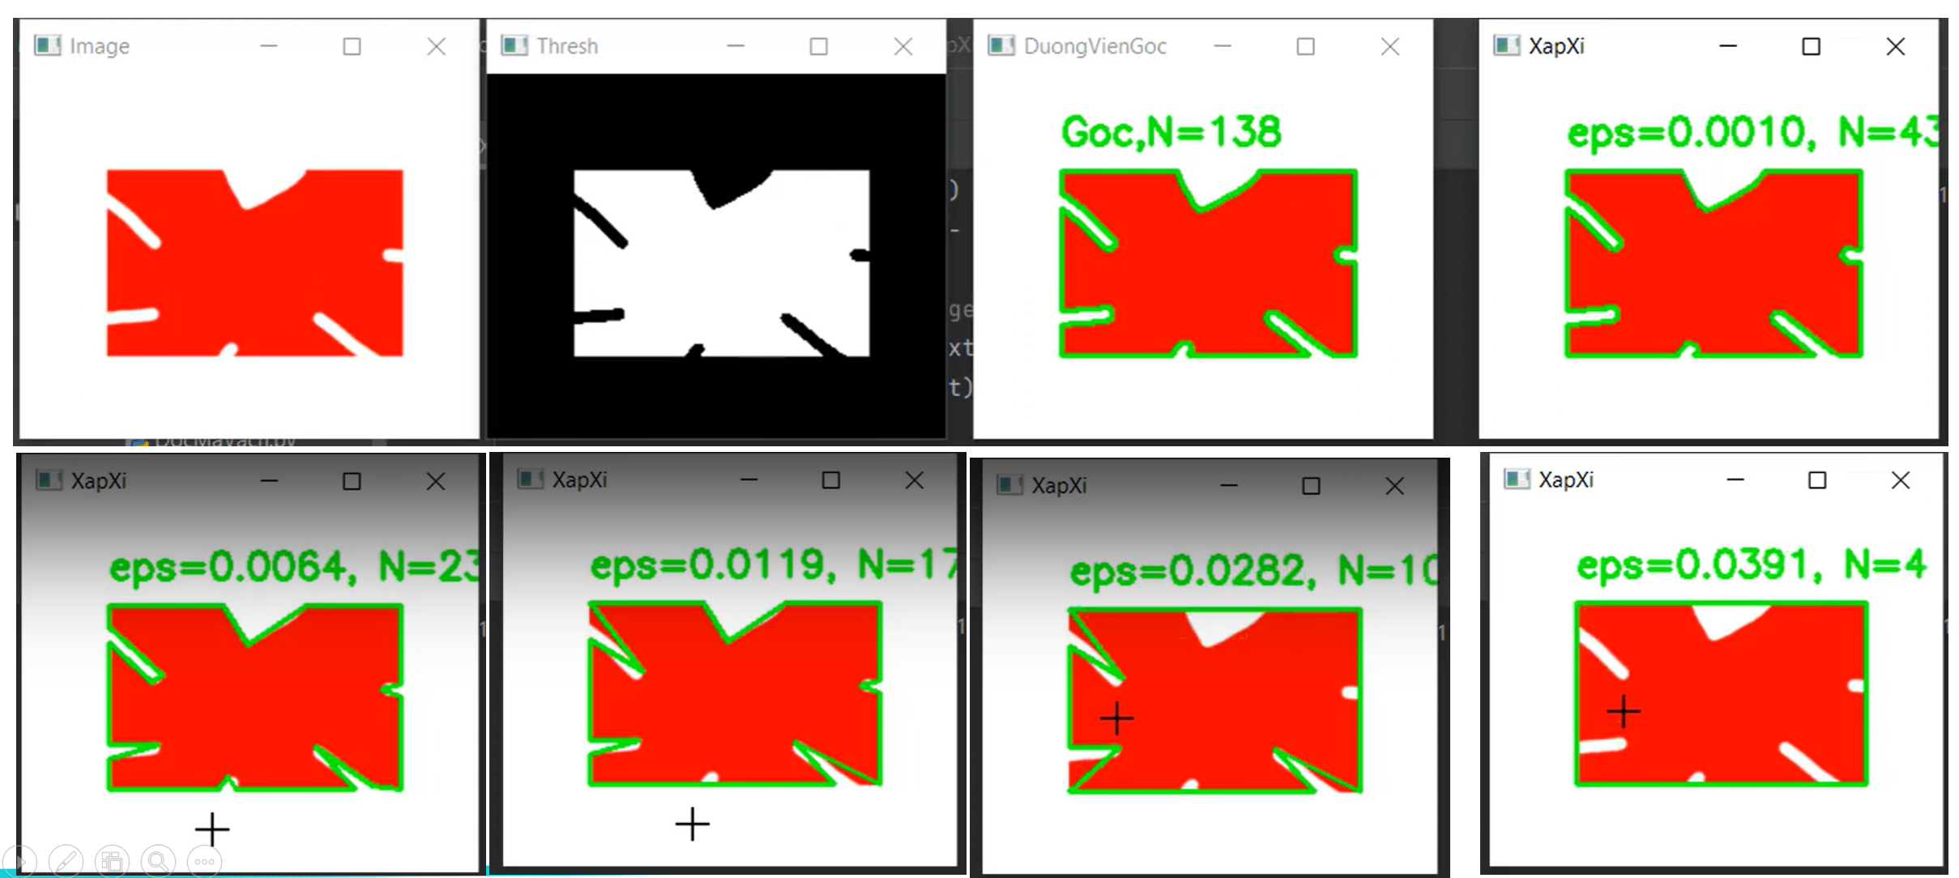

Figure 3-7: Result of contour approximation function.

## Control block diagram, wiring diagram and algorithm flow chart

### Control block diagram

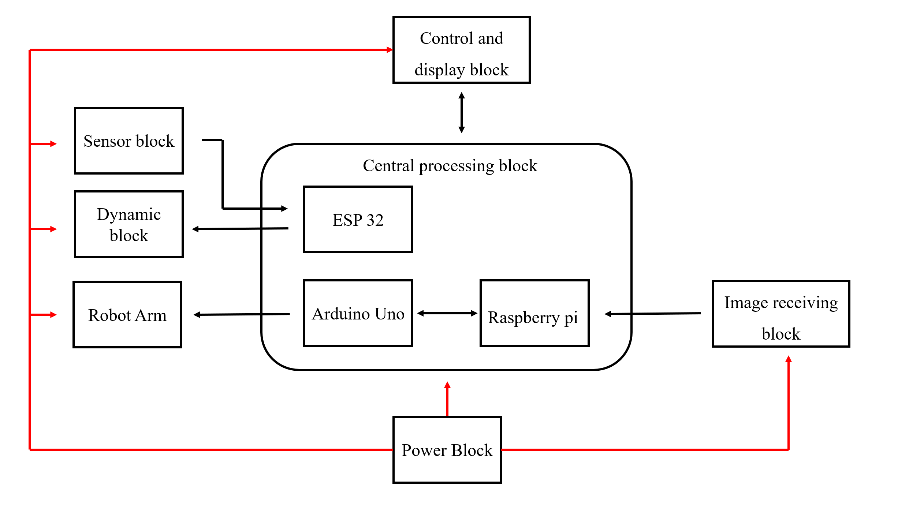

Figure 3-8: Block diagram.

* **Central processing block:**

The central processing block will include Arduino Uno R3, ESP32 and Raspberry PI 4B+, Arduino and Rpi4 communicate with each other via USB communication standard. Raspberry will receive image data from the image acquisition block and process the image then send the data via Arduino. Arduino will receive data from Raspberry and issue control signals sent to the robot arm.

* **Image acquisition block:**

Responsible for acquiring images of the above products conveyor and send data to Raspberry. The block will include specialized cameras and LED system helps provide light so the camera can accurately capture images product shapes and colors.

* **Sensor block:**

Powered by the power block, the block will include 2 sensors infrared. Infrared sensors are responsible determine the locations of products sent to the processing center for conveyor control.

* **Dynamic block:**

Includes conveyor belt and vacuum pump motor powered by the source block and will receive control commands from the processing block center. The conveyor motor will be controlled by esp32 and the vacuum pump motor will be controlled by Arduino.

* **Control and display block:**

This is a block designed for communication between people and machines, play an extremely important role. The block includes an LCD screen that displays the system settings and buttons and indicator lights to control the entire system.

* **Power block:**

Responsible for providing a stable power source for the central processing block

Arduino, Raspberry, ESP32 and functional blocks such as display block, sensor block, dynamic block. [1] [3]

### Flow chart

#### Algorithm flow chart for image processing

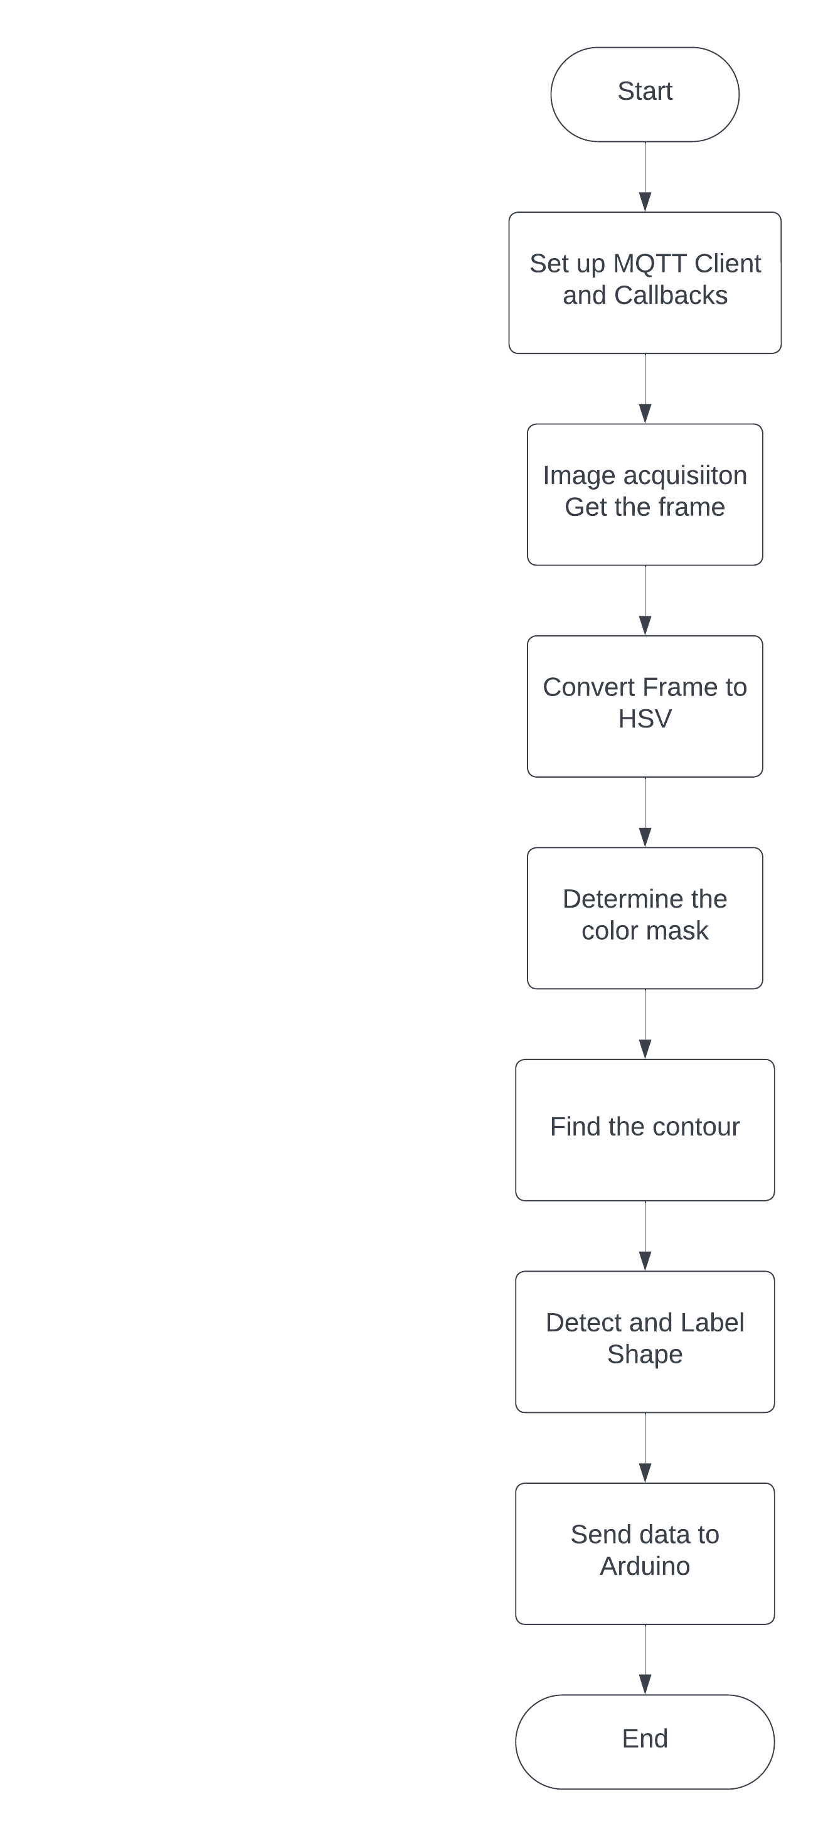

Figure 3-9: Flow chart for image processing.

#### Algorithm flow chart for Robot arm

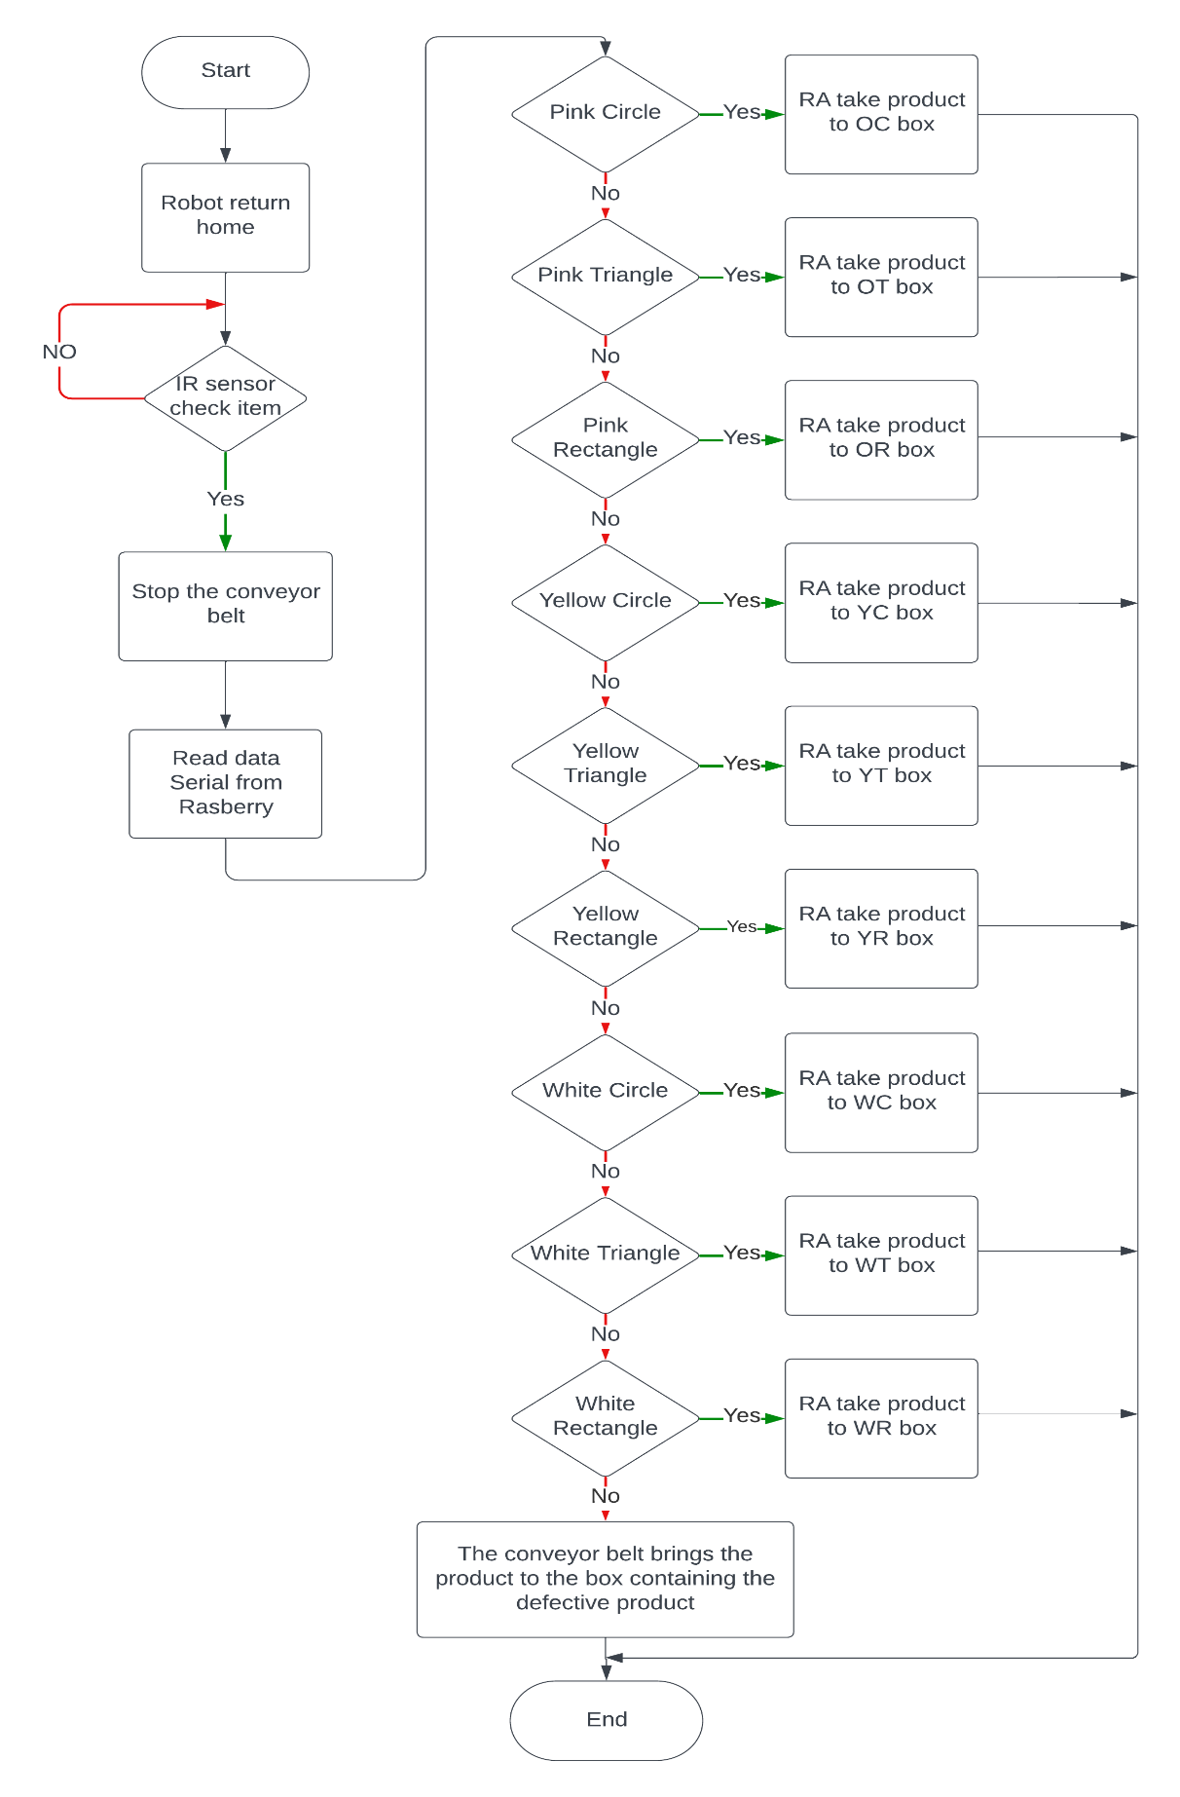

Figure 3-10: Flow chart for Robot arm.

### Wiring dìgram

Power supply for CNC Shield V3. CNC shield V3 connects joints 1,2,3 of the Robot through the X, Y, Z axis respectively. Limit switches on joints 1,2,3 are used to determine the value of the Robot joints when connected. Connect to X, Y, Z pins of CNC Shield V3.

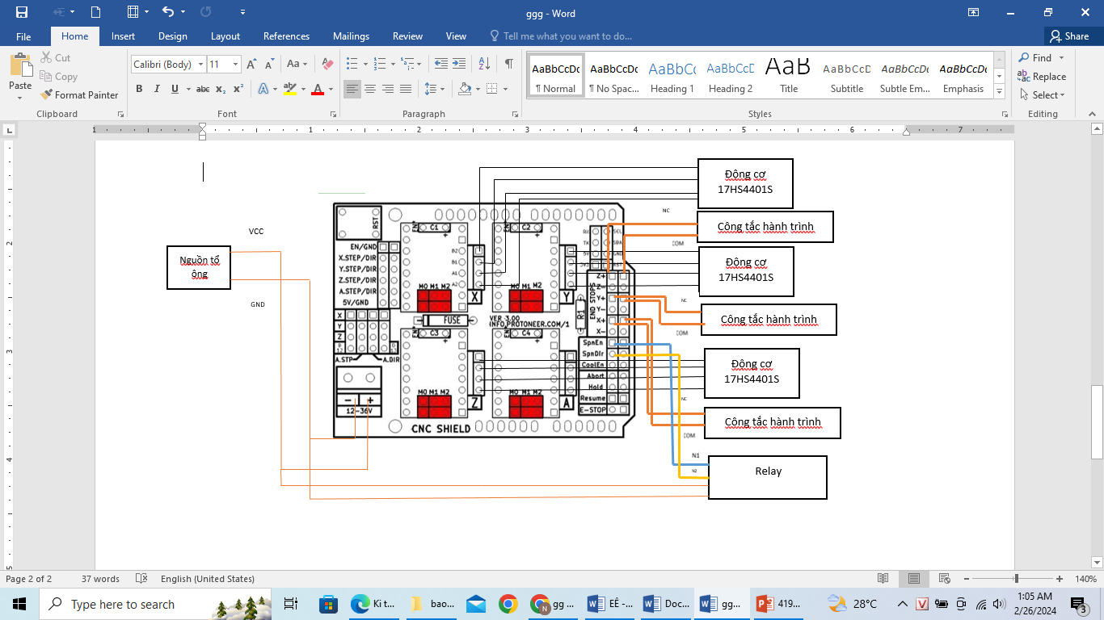

Figure 3-10: Wiring diagram of stepper motor control block.

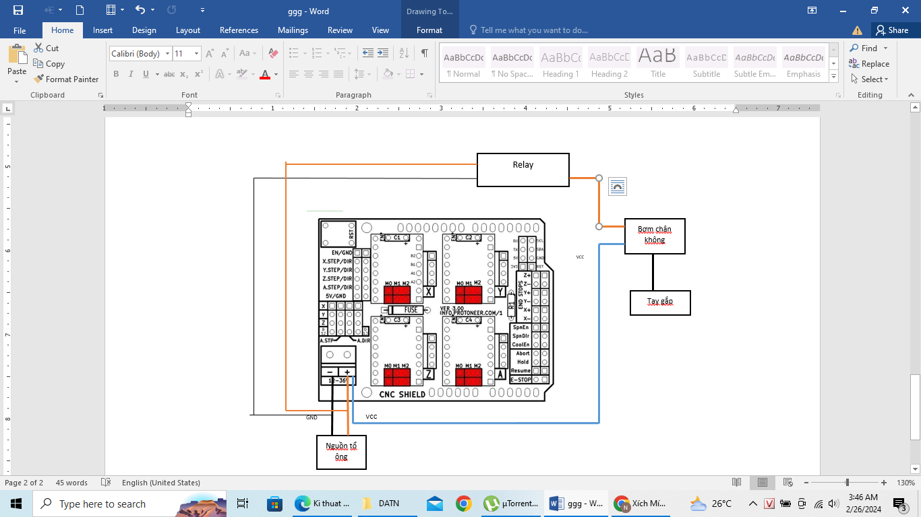

Figure 3-11: Wiring diagram of vacuum pump on/off circuit.

### Step-down converter

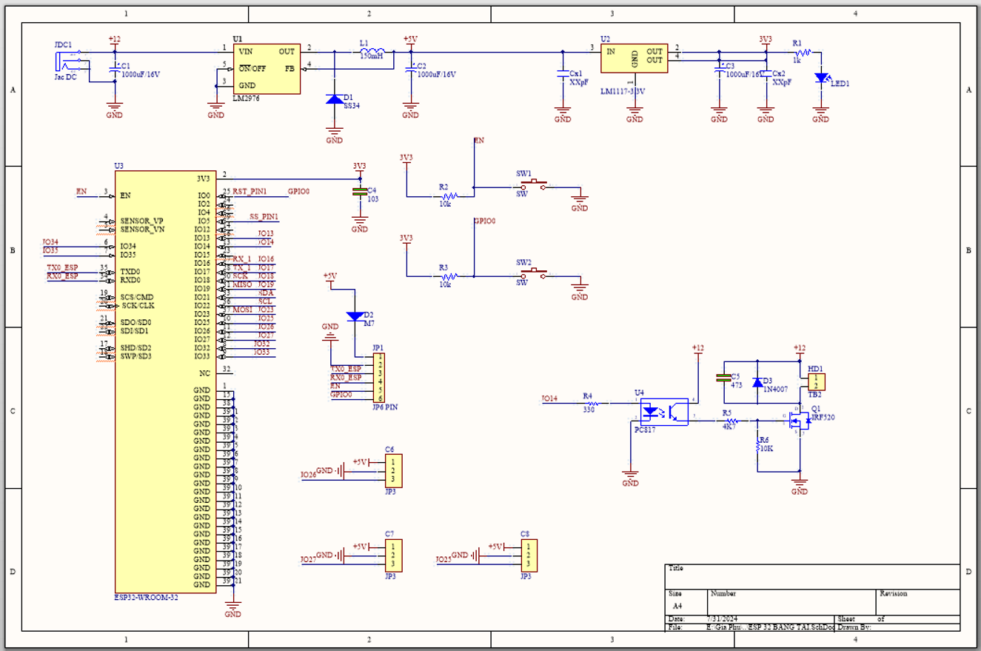

Figure 3-11: Step-down converter.

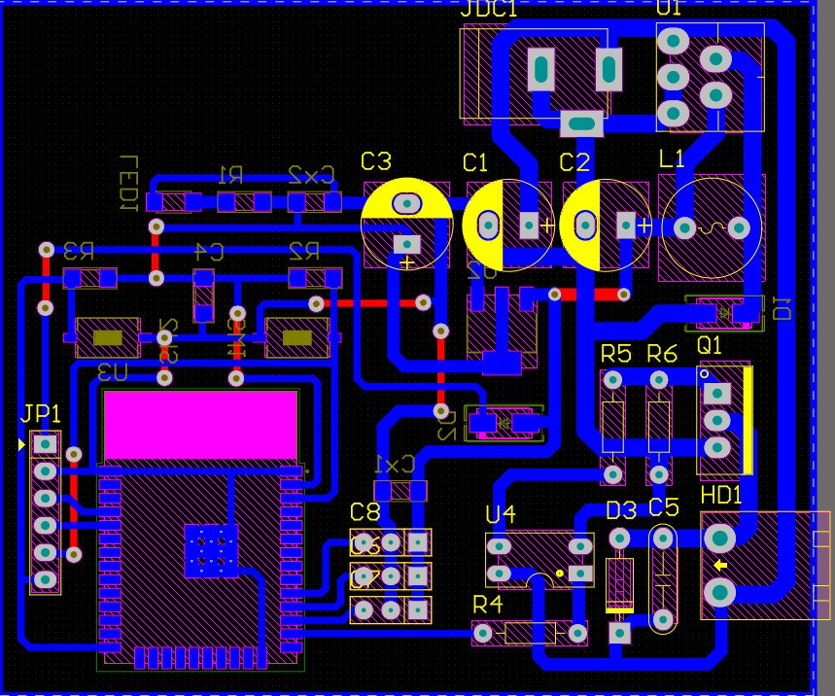

Figure 3-12: PCB of step-down converter.

1. CONSTRUCTION AND EXPERIMENT

## Construction

* **Design of robot arm mechanical system**

Robot arm structures are manufactured depending on the type of robot, purpose of use, user needs, etc., and will have different shapes but still have the same basic components such as manipulator arm, power source, controller. control. The manipulator will contain mechanical parts with corresponding moving blocks.

### Transmission Assembly for the First Rotational Joint

Since the first rotational joint is a rotating joint, in this model, the motor is indirectly connected to the motor shaft through gears. However, there are pros and cons to using direct transmission. The advantages include a low-cost model that is easy to maintain, with low maintenance costs and frequency. However, indirect transmission can make the model prone to slipping due to low transmission efficiency and low precision.

Here, a belt drive system is used, which has notable features: it can transmit power over long distances between shafts A and B, operates quietly, reduces the risk of overload due to its elasticity, and is simple to operate and maintain. Additionally, belt drives are relatively inexpensive and can absorb shock loads, which can help protect the motor and other components from damage. However, there are also disadvantages: elasticity can lead to transmission errors, and it is best to avoid using it in environments with excessively high temperatures.

Figure 4-1: Belt transmission.

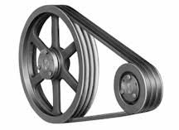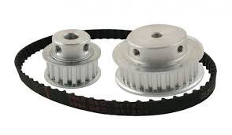

However, there are also disadvantages: elasticity can lead to transmission errors, and it is best to avoid using it in environments with excessively high temperatures. Furthermore, belts can wear out over time and may require periodic replacement, and their performance can be affected by environmental conditions such as humidity and dust.

To mitigate some of these issues, it is important to regularly inspect and maintain the belt drive system, ensuring that the belts are properly tensioned and aligned. Using high-quality belts and pulleys can also improve the overall performance and longevity of the system. Additionally, considering alternative transmission methods, such as timing belts or chains, might be beneficial in certain applications where higher precision and reliability are required.

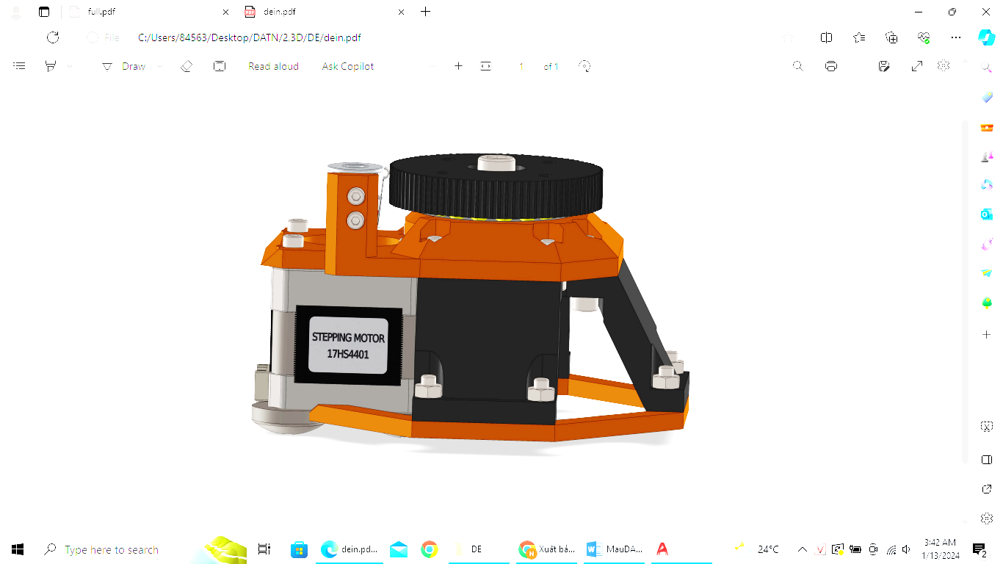

Figure 4-2: 3D drawing of the first rotary joint.

### Transmission Assembly for the Second Rotational Joint

Similar to the first rotational joint, the second joint also uses the stepper motor 17HS4401S with the same technical specifications as mentioned above.

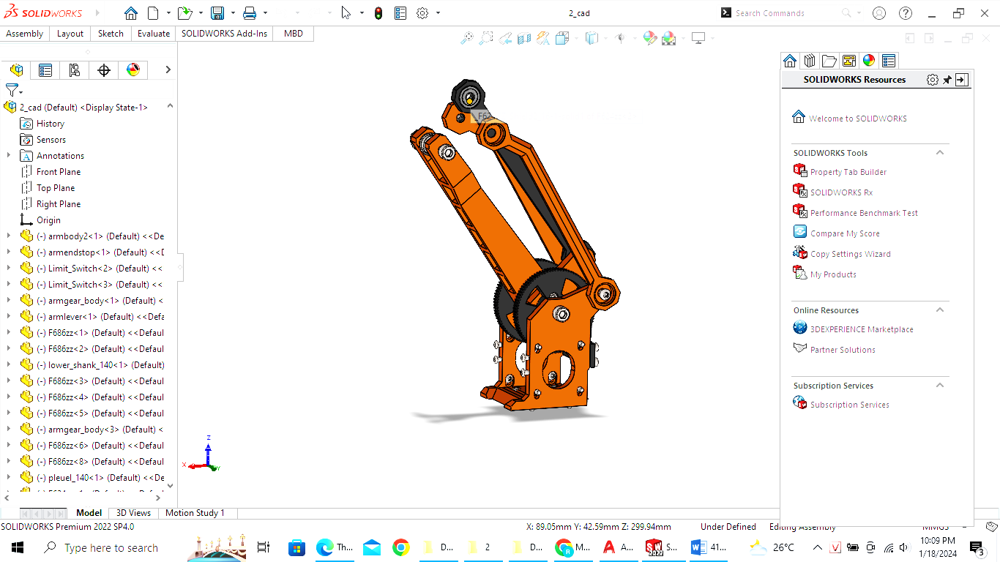

Figure 4-3: 3D drawing of the second rotary joint.

### Transmission Assembly for the Third Rotational Joint

Similar to the first and second rotational joints, the third joint also uses the stepper motor 17HS4401S with the same technical specifications as mentioned above.

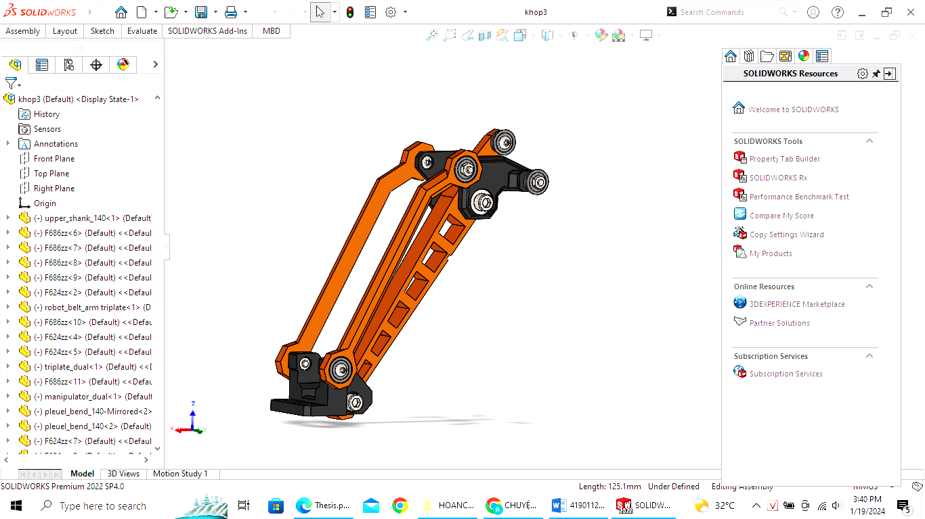

Figure 4-4: 3D drawing of the third rotary joint.

### Gripper Assembly

The gripper assembly uses the suction force of a cylinder. Its advantages include a simple structure, large suction force due to pneumatic operation, easy control, and straightforward operation and maintenance. However, there are also disadvantages such as the need for a flat surface and ensuring the system can provide sufficient suction force.

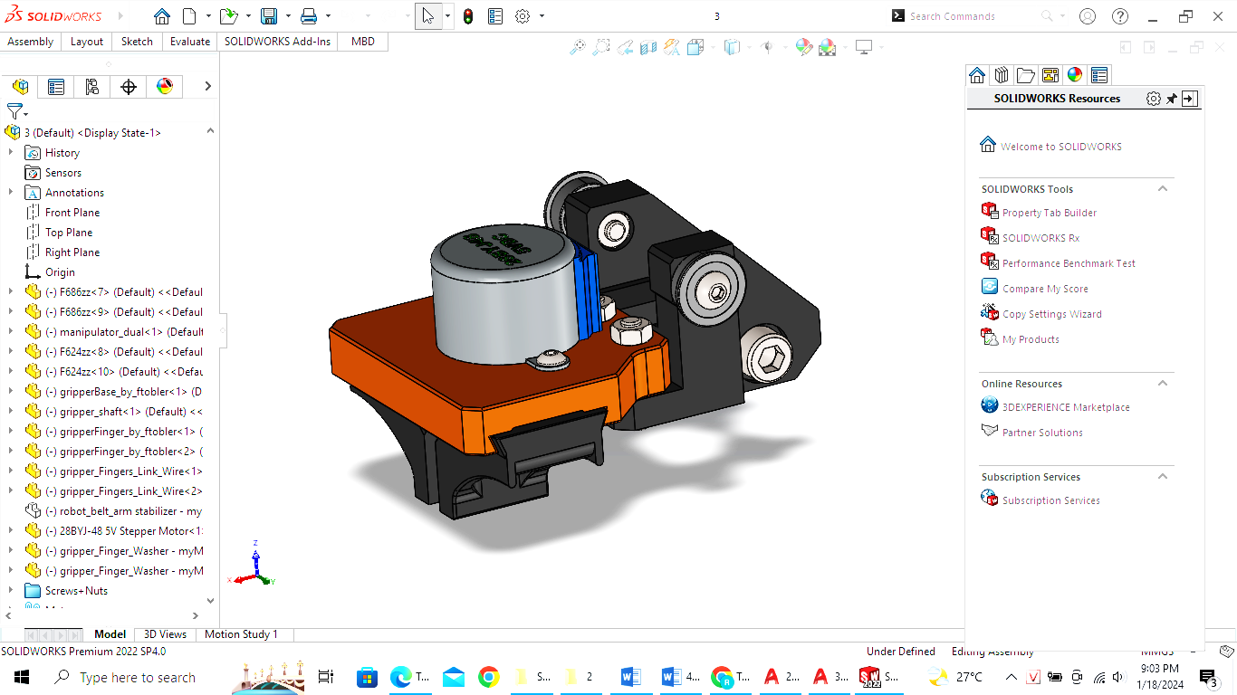

Figure 4-5: 3D drawing of the Gripper Assembly.

### Overview of the Robot arm

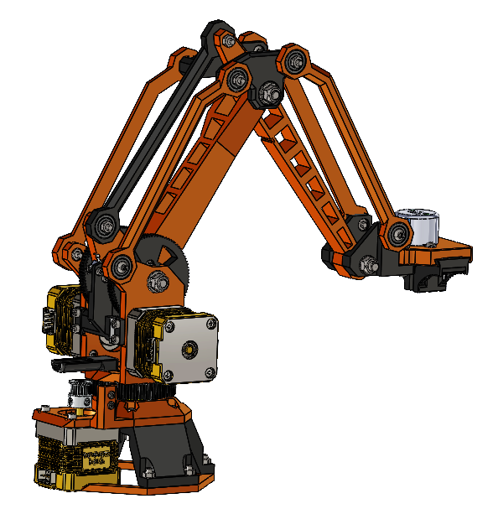

Figure 4-6: 3D drawing of the Robot Arm.

## Construction of realistic models

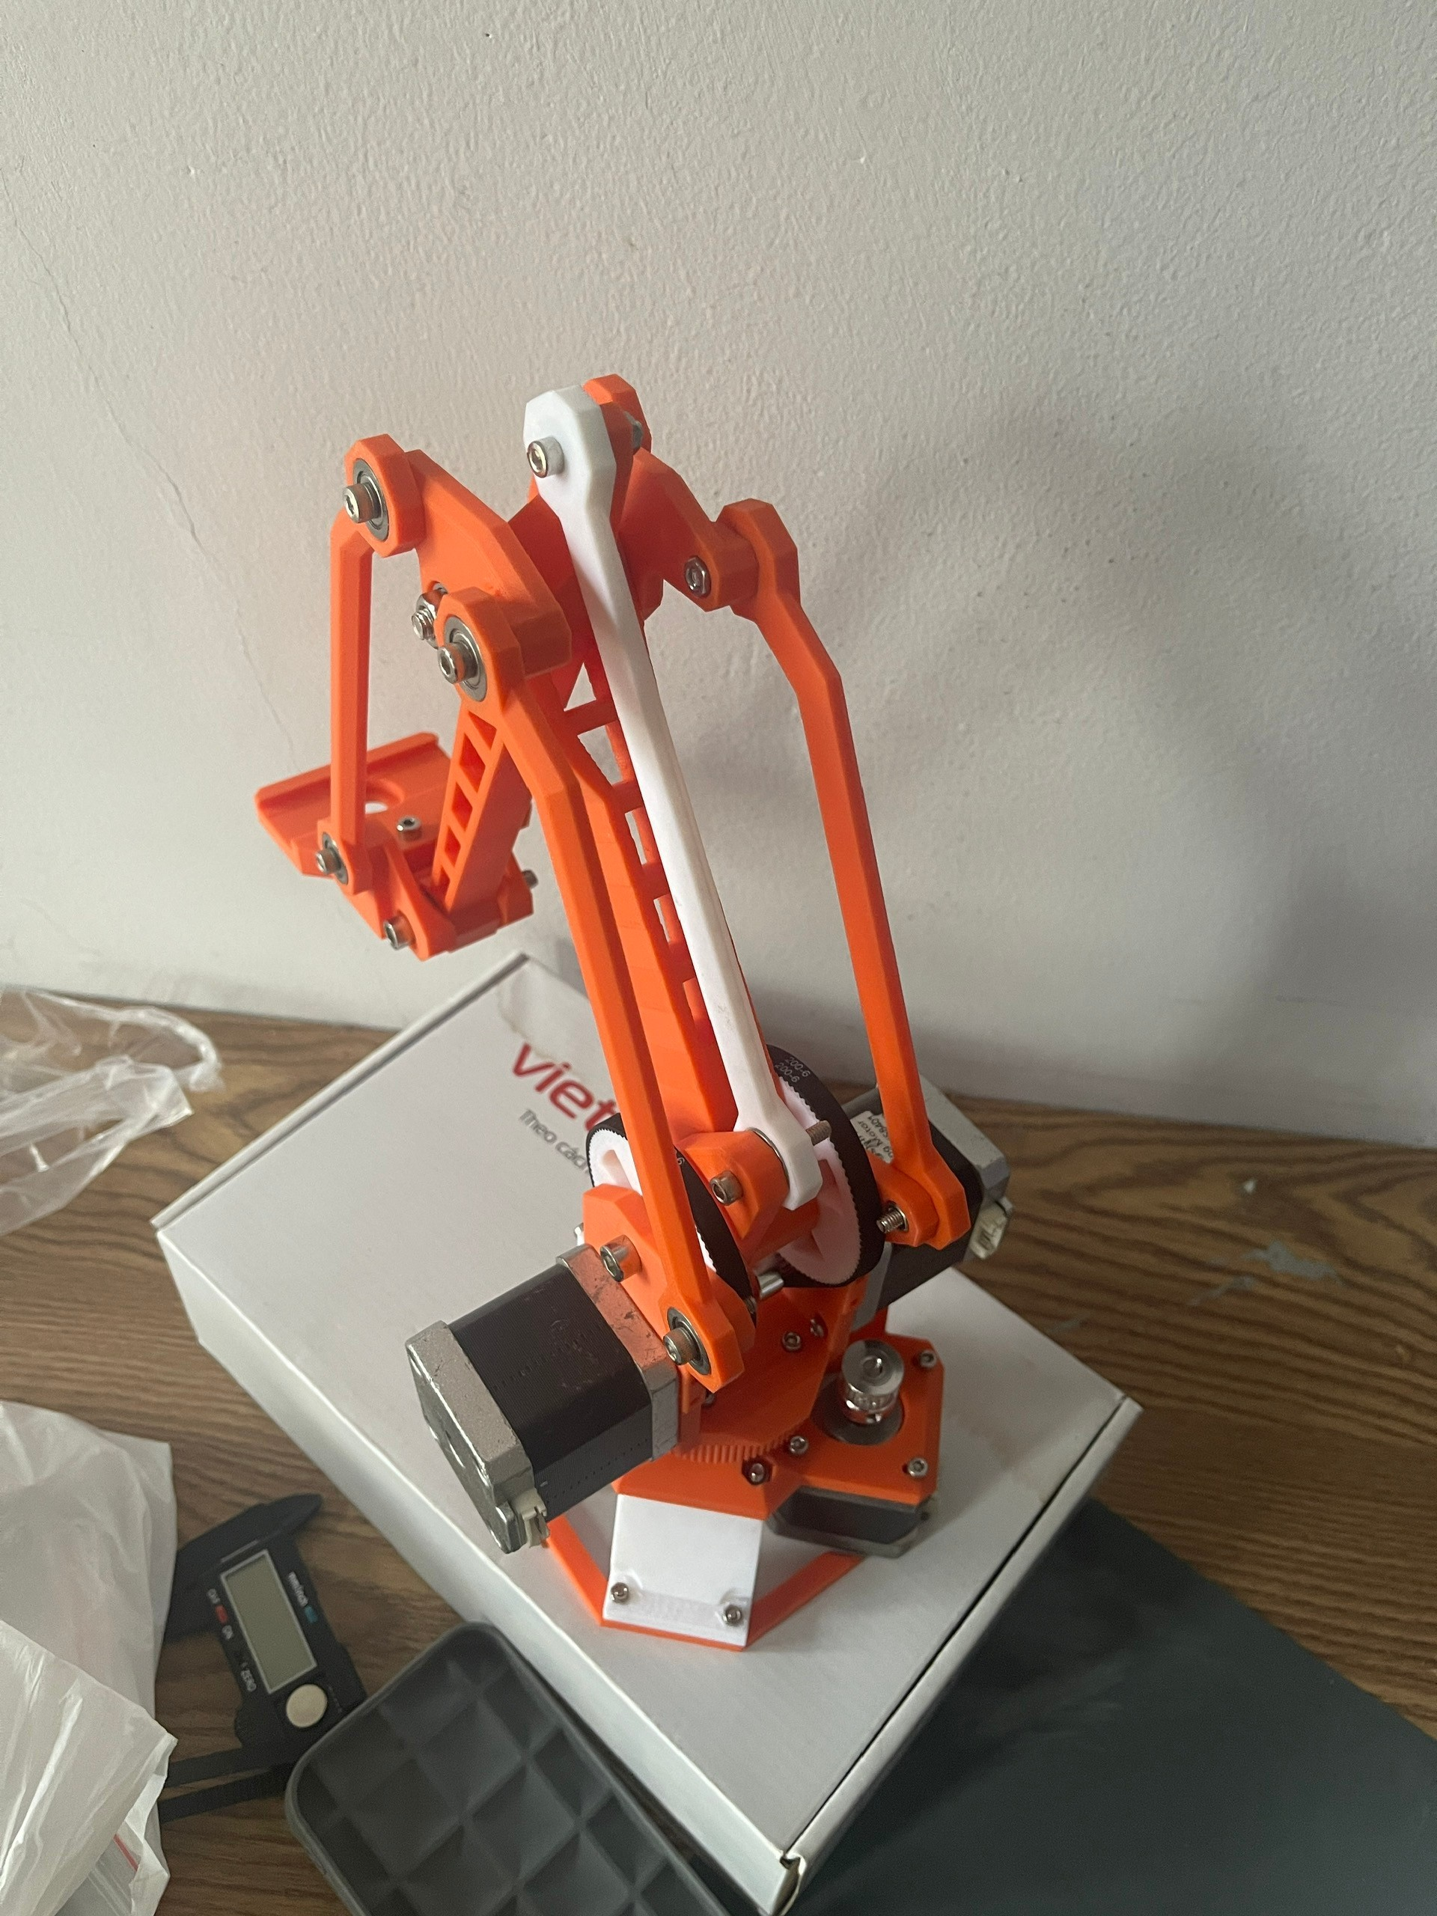

Figure 4-7: Robot arm is printed from the drawing board.

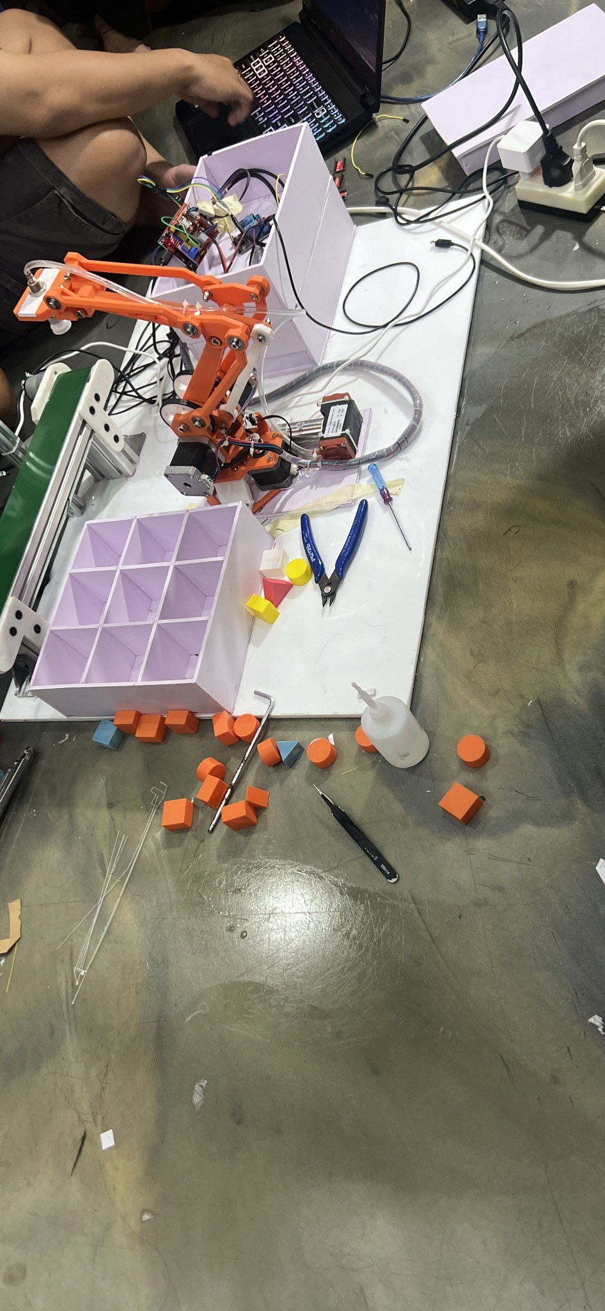

Figure 4-8: Overview of the actual system.

## Build the display interface

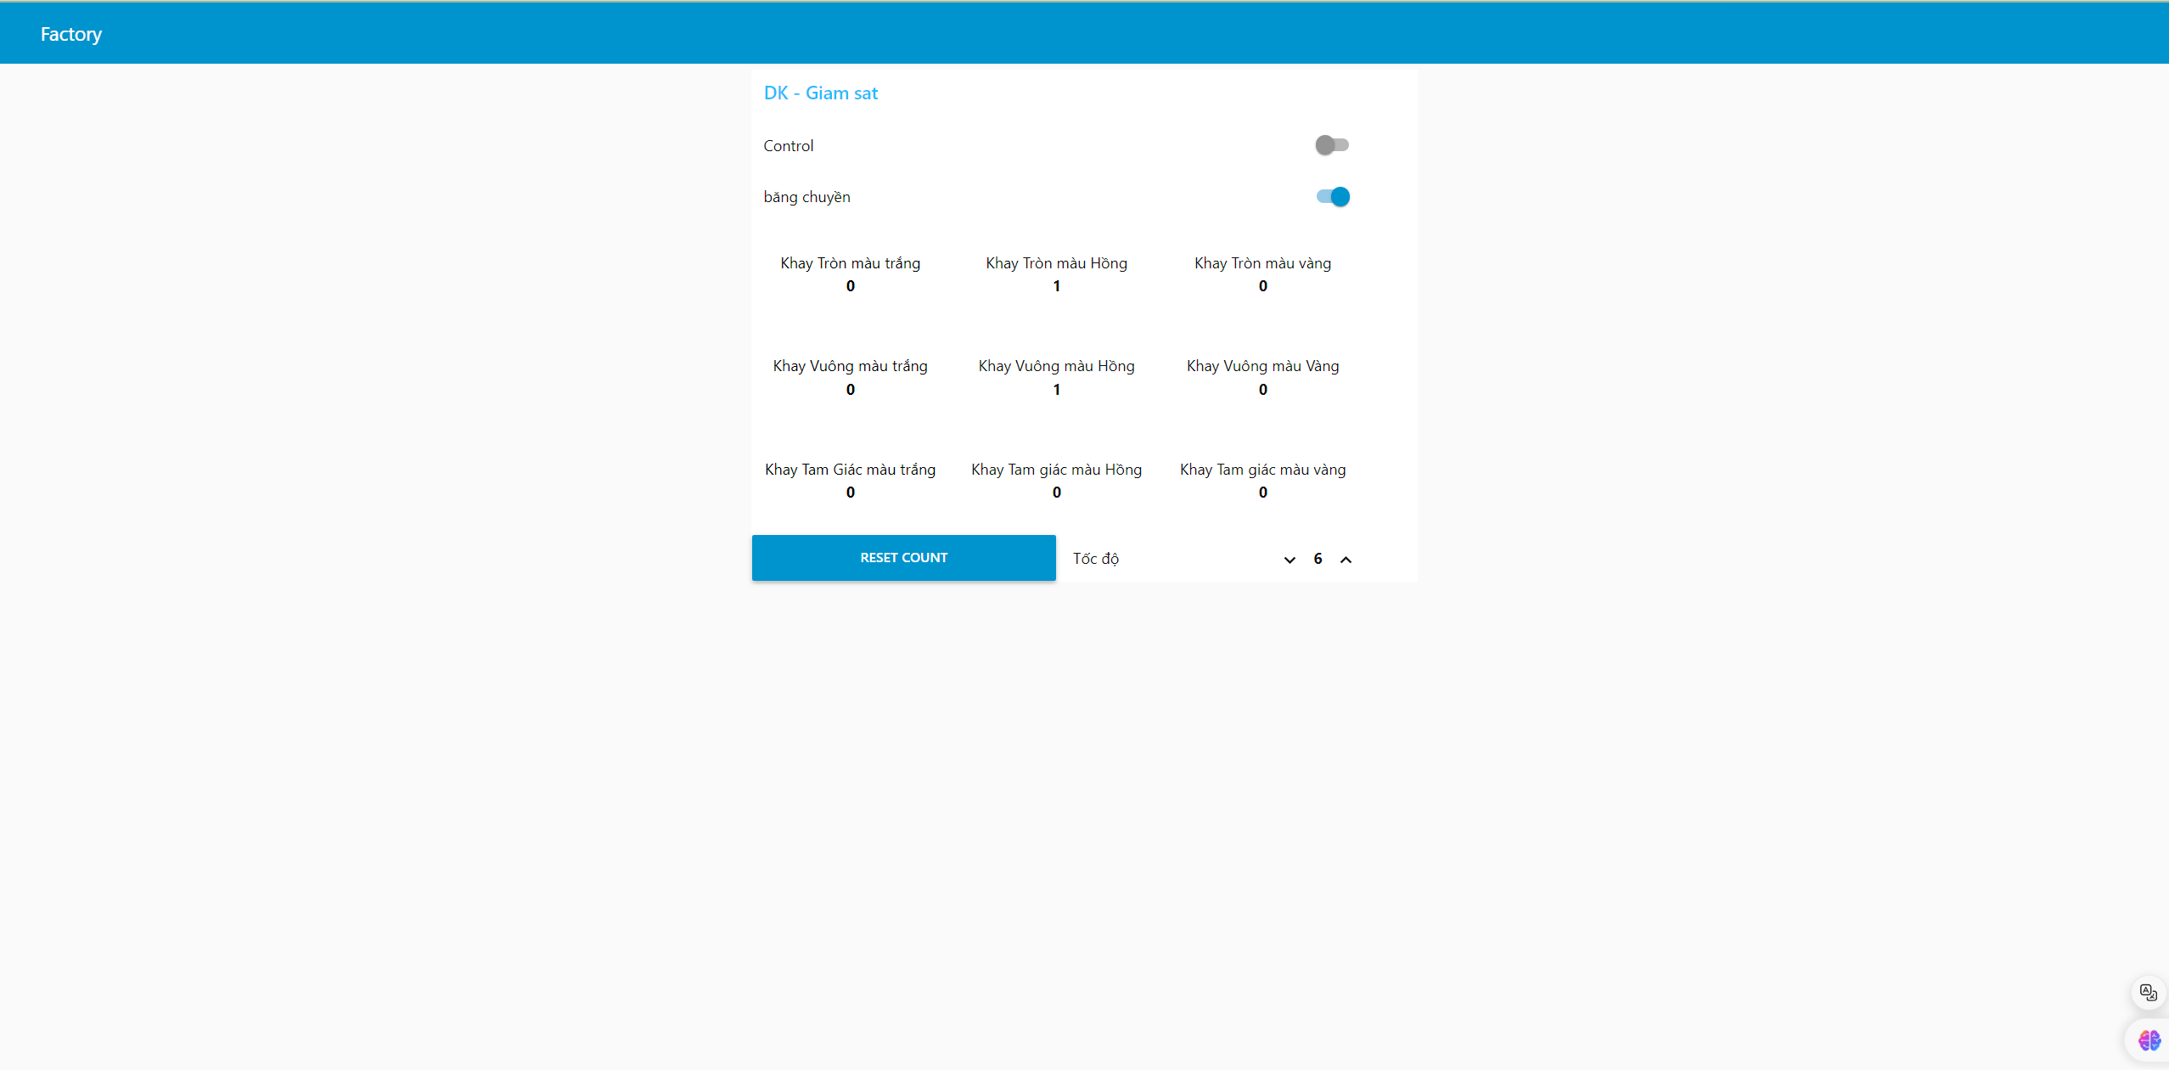

Figure 4-9: Interface displayed on node-red.

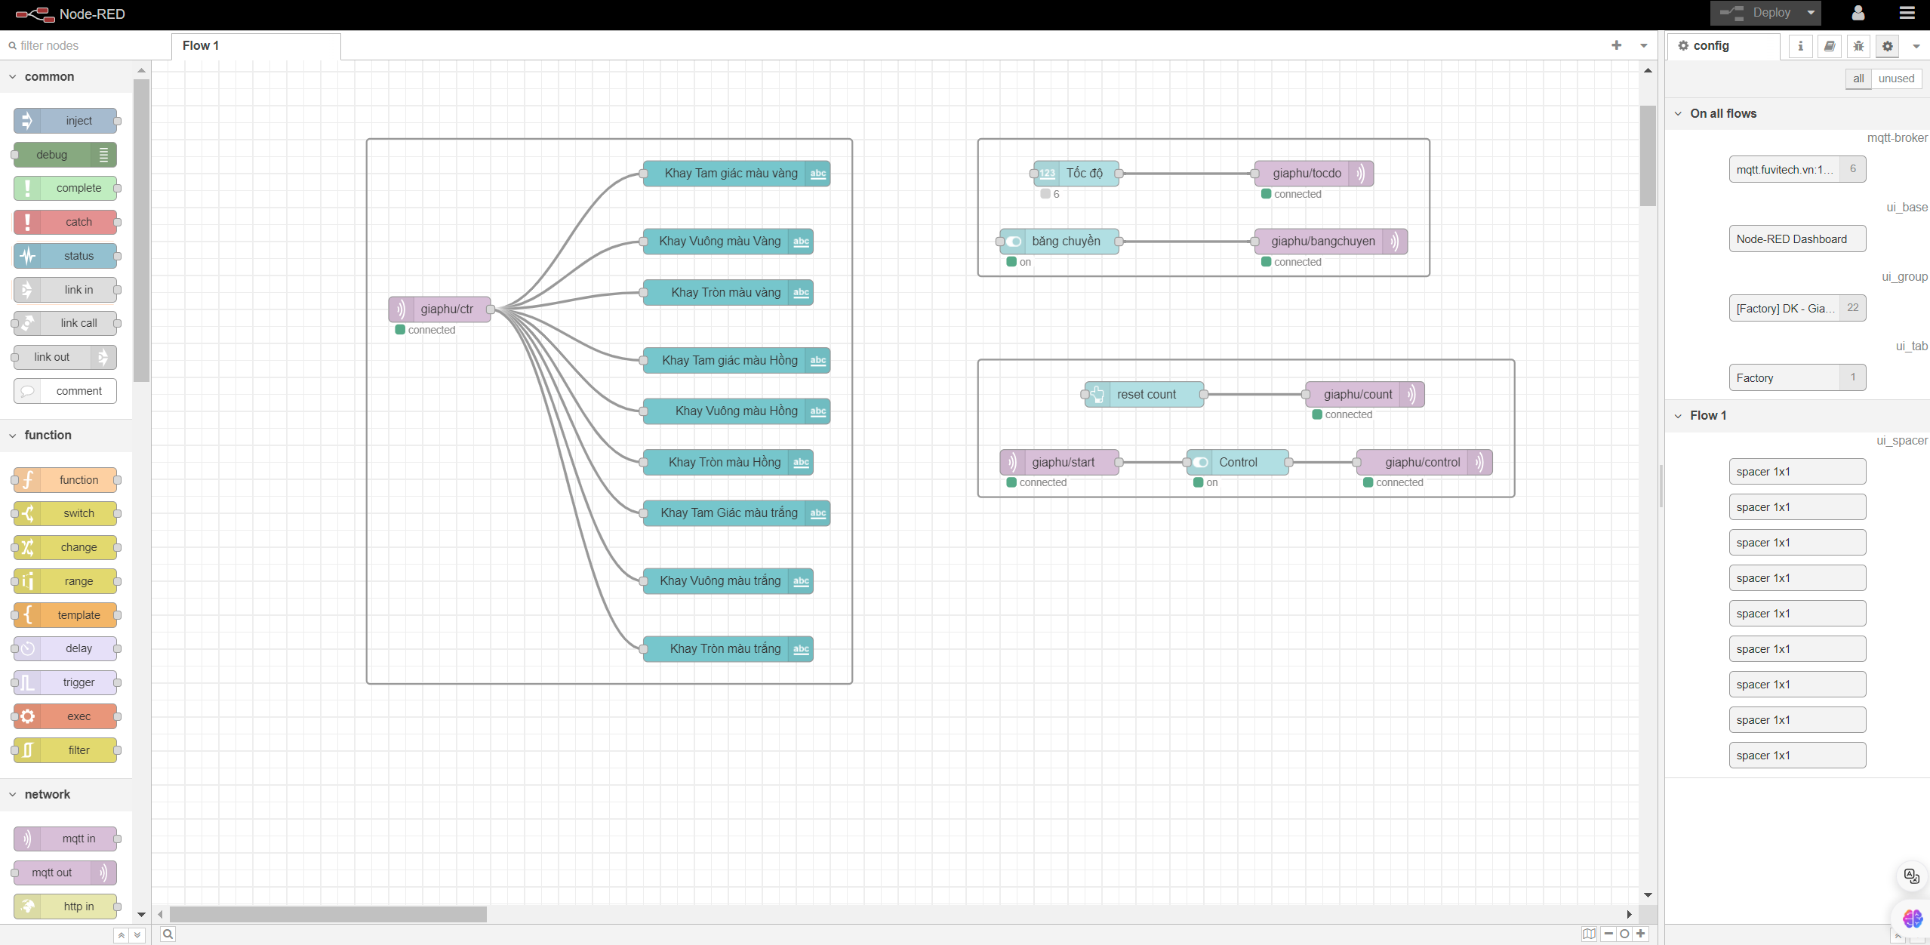

Figure 4-10: Interface code displayed on node-red.

## Experimental process

Step 1: Supply power using a 5VDC-3A adapter for Rpi4 and 220VAC for 12VDC Switching Power Supply

Step 2: Put product on conveyor belt

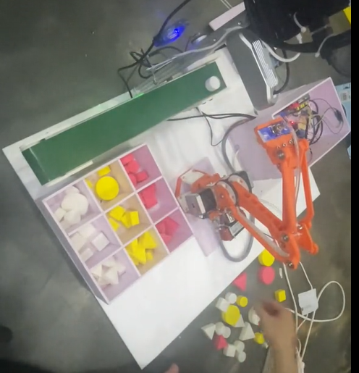

Figure 4-11: Put product on conveyor belt.

Step 3: The object is color and shape processed on Rpi4 and the relevant values are output

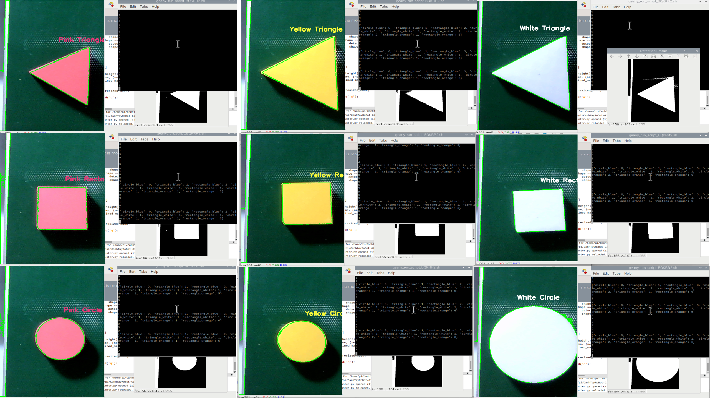

Figure 4-12: Detect color and label shape.

Step 4: Web-based control and monitoring

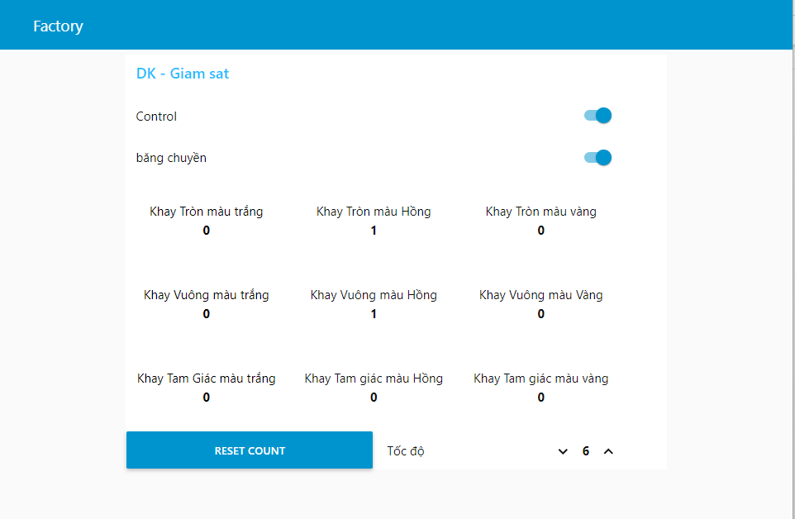

Figure 4-13: Web-based control and monitoring.

## Experimental results

Table 4-1: Experimental table of model accuracy.

|  |  |  |  |  |
| --- | --- | --- | --- | --- |
| **No** | **Product** | **Right/Wrong** | **Number of picks** | **Note** |
| 1 | Pink Triangle | Right | 2 |  |
| 2 | Pink Rectangle | Wrong | 1 | Incorrect color classification due to glare leading to incorrect color processing |
| 3 | Pink Circle | Right | 3 | Sliding gripper robot arm |
| 4 | Yellow Triangle | Wrong | 2 | Wrong shape classification due to product being off the conveyor belt |
| 5 | Yellow Rectangle | Right | 5 | Sliding gripper robot arm |
| 6 | Yellow Circle | Right | 2 |  |
| 7 | White Triangle | Wrong | 1 | Inaccurate color grading due to robot interference leading to inaccurate color processing |
| 8 | White Rectangle | Right | 2 |  |
| 9 | White Circle | Right | 3 |  |

Table 4-1: Experimental table of model accuracy.

1. CONCLUSION

## Advantages

* Capable of processing colors and classifying products, picking and placing objects in the desired positions as specified by the user.
* Building a user interface to display basic information: showing the number of products by color, monitoring the image processing process.
* A compact model that solves the problems of space and flexibility.

## Disadvantages

* Due to the low quality of the webcam, it is easily affected by light interference, leading to errors in environments with poor lighting or excessive light. Switching to color sensors can increase the accuracy of color differentiation.
* The robot is controlled in an open loop, resulting in low accuracy; it is necessary to solve the trajectory planning problem for the robot arm.
* When the motor works too much, it overheats, causing step loss.
* The control program is not yet optimized.
* The aesthetic aspect of the model is still low, and issues related to installation and wiring have not been resolved to make the model more optimal.

## Development

* Replace stepper motors with servo motors for greater power and to prevent slipping when the motor overheats.
* To calibrate the joints more accurately in CNC applications, use sensors instead of limit switches.
* Build a closed-loop system to control any position and develop trajectory planning for the robot.
* Develop an optimized control program and expand additional functions such as shape, weight, QR, and face recognition.

# REFERENCES

**VIETNAMESE:**

1. Bugs. (2024, March 21). *Xử LÝ Ảnh Với opencv: Các Phép Toán Hình Thái Học*. IO Stream. https://www.iostream.co/article/xu-ly-anh-voi-opencv-cac-phep-toan-hinh-thai-hoc-Nljcg
2. Xử lý ảnh cơ bản trong Python | MMLab UIT. (n.d.). MMLab UIT. <https://mmlab.uit.edu.vn/tutorials/cv/basic/pixel_wised_transform>

**ENLISH:**

1. Nguyễn, T. H. (2020). Image processing. Đại học Sư Phạm Kĩ Thuật.
2. Xie, G., & Lu, W. (n.d.). Image edge detection based on OpenCV. School of Computer, Guangdong University of Technology, Guangzhou, China. E-mail: guoboxie@163.com, [lu_wenwen@163.com](mailto:lu_wenwen@163.com).

APPENDIX A: ARDUINO SOURCE CODE

#include <AccelStepper.h>

#include <Wire.h>

#define E_X 9

#define E_Y 10

#define E_Z 11

#define irPin A0

#define relayPin 12

#define relayPin1 13

int StepX = 2;

int DirX = 5;

int StepY = 3;

int DirY = 6;

int StepZ = 4;

int DirZ = 7;

int ena = 8;

unsigned long startTime;

int flag = 0;

AccelStepper mystepperX(1, StepX, DirX, ena);

AccelStepper mystepperY(1, StepY, DirY, ena);

AccelStepper mystepperZ(1, StepZ, DirZ, ena);

const int positionX[] = {-270, -200, -150, -270, -225, -185, -270, -230, -200}; // Các vị trí cần đến

const int positionY[] = {-100, -100, -150, -150, -150, -190, -210, -220, -250};

const int positionZ[] = {200, 200, 200, 150, 150, 150, 100, 100, 100};

void home_YZ()

{

  int homeY = 0;

  int homeZ = 0;

  mystepperY.setMaxSpeed(100);

  mystepperY.setAcceleration(100);

  mystepperY.enableOutputs();

  mystepperZ.setMaxSpeed(100);

  mystepperZ.setAcceleration(100);

  mystepperZ.enableOutputs();

  while (digitalRead(E_Y) == 1 && digitalRead(E_Z) == 1)

  {

    mystepperY.moveTo(homeY);

    mystepperZ.moveTo(homeZ);

    homeY++;

    homeZ--;

    mystepperY.run();

    mystepperZ.run();

  }

  while (digitalRead(E_Y) == 1)

  {

    mystepperY.moveTo(homeY);

    homeY++;

    mystepperY.run();

  }

  mystepperY.setCurrentPosition(0);

  while (digitalRead(E_Z) == 1)

  {

    mystepperZ.moveTo(homeZ);

    homeZ--;

    mystepperZ.run();

  }

  mystepperZ.setCurrentPosition(0);

  homeY = 0;

  homeZ = 0;

}

void home_X()

{

  int homeX = 0;

  mystepperX.setMaxSpeed(100);

  mystepperX.setAcceleration(100);

  mystepperX.enableOutputs();

  while (digitalRead(E_X) == 1)

  {

    mystepperX.moveTo(homeX);

    homeX++;

    mystepperX.run();

  }

  mystepperX.setCurrentPosition(0);

  homeX = 0;

}

void home()

{

  home_YZ();

  home_X();

}

void setup()

{

  Serial.begin(115200);

  pinMode(irPin, INPUT);

  pinMode(relayPin, OUTPUT);

  digitalWrite(relayPin, LOW);

  pinMode(relayPin1, OUTPUT);

  digitalWrite(relayPin1, HIGH);

  pinMode(E_X, INPUT_PULLUP);

  pinMode(E_Y, INPUT_PULLUP);

  pinMode(E_Z, INPUT_PULLUP);

  home();

  mystepperX.setMaxSpeed(200);

  mystepperX.setAcceleration(200);

  mystepperY.setMaxSpeed(200);

  mystepperY.setAcceleration(200);

  mystepperZ.setMaxSpeed(200);

  mystepperZ.setAcceleration(200);

}

void Position(int X, int Y, int Z)

{

  mystepperX.moveTo(X);

  mystepperY.moveTo(Y);

  mystepperZ.moveTo(Z);

  while (mystepperX.distanceToGo() != 0 || mystepperY.distanceToGo() != 0 || mystepperZ.distanceToGo() != 0)

    mystepperX.run();

    mystepperY.run();

    mystepperZ.run();

}

void Position_home(int Y, int Z)

{

  mystepperY.moveTo(Y);

  mystepperZ.moveTo(Z);

  while (mystepperY.distanceToGo() != 0 || mystepperZ.distanceToGo() != 0)

  {

    mystepperY.run();

    mystepperZ.run();

  }

}

void loop()

{

  int i;

  String receivedChar = Serial.readString();

  i = receivedChar.toInt();

  if(i == 10){

    digitalWrite(relayPin, HIGH);

    Serial.println("i==10");

  }else

  if (digitalRead(irPin) == 0)

  {

    delay(80);

    Serial.println(digitalRead(irPin));

    digitalWrite(relayPin, HIGH);

    delay(3000);

    if (Serial.available() > 0)

    {

      String receivedChar = Serial.readString();

      i = receivedChar.toInt();

      while (i == 9 && digitalRead(irPin) == 0)

      { // pass

        digitalWrite(relayPin, LOW);

        delay(1000);

        String receivedChar = Serial.readString();

        i = receivedChar.toInt();

      }

      digitalWrite(relayPin, HIGH);

        while (i == 0 || i == 1 || i == 2 || i == 3 || i == 4 || i == 5 || i == 6 || i == 7 || i == 8)

        {

          digitalWrite(relayPin1, LOW);

          Serial.println(digitalRead(irPin));

          Position(-65, -163, 133);

          delay(500);

          home();

          if (digitalRead(irPin) == 0)

          {

            Position(-60, -163, 133);

            delay(500);

            home();

          }

          if (digitalRead(irPin) == 0)

          {

            Position(-65, -160, 133);

            delay(500);

            home();

          }

          if (digitalRead(irPin) == 0)

          {

            Position(-60, -160, 133);

            delay(500);

            home();

          }

          if (digitalRead(irPin) == 1)

          {

            Position(positionX[i], positionY[i], positionZ[i]);

            digitalWrite(relayPin1, HIGH);

            delay(2500);

            home();

            if (Serial.available() > 0)

            {

              receivedChar = Serial.readString();

              i = receivedChar.toInt();

            }

            i = 10;

          }

        }

    }

  }

  else

  {

    digitalWrite(relayPin, LOW);

}

APPENDIX B: PYTHON SOURCE CODE

import cv2

import numpy as np

import json

import paho.mqtt.client as mqtt

import serial

import threading

try:

    ser = serial.Serial('/dev/ttyUSB4', 115200, timeout=1)

except:

    ser = serial.Serial('/dev/ttyUSB1', 115200, timeout=1)

def detect_and_label_shapes(contours, frame, label, color):

    detected_shapes = []

    for contour in contours:

        area = cv2.contourArea(contour)

        if area > 10000:

            cv2.drawContours(frame, [contour], -1, (0, 255, 0), 2)

            perimeter = cv2.arcLength(contour, True)

            approx = cv2.approxPolyDP(contour, 0.03 * cv2.arcLength(contour, True), True)

            if len(approx) == 3:

                detected_shapes.append((label, "Triangle"))

                cv2.putText(frame, f"{label} Triangle", (x + 120, y - 30), cv2.FONT_HERSHEY_SIMPLEX, 1, color, 4)

            elif len(approx) == 4:

                detected_shapes.append((label, "Rectangle"))

                cv2.putText(frame, f"{label} Rectangle", (x + 120, y - 30), cv2.FONT_HERSHEY_SIMPLEX, 1, color, 4)

            elif len(approx) > 7:

                detected_shapes.append((label, "Circle"))

                cv2.putText(frame, f"{label} Circle", (x + 120, y - 30), cv2.FONT_HERSHEY_SIMPLEX, 1, color, 4)

    return detected_shapes

cap = cv2.VideoCapture(0)

object_counter_triangle_pink = 0

object_counter_rectangle_pink = 0

object_counter_circle_pink = 0

object_counter_triangle_yellow = 0

object_counter_rectangle_yellow = 0

object_counter_circle_yellow = 0

object_counter_triangle_white = 0

object_counter_rectangle_white = 0

object_counter_circle_white = 0

detectFlag = 0

shape_code = 9

# Cấu hình MQTT broker

broker = "mqtt.fuvitech.vn"

port = 1883

topic = "giaphu/ctr"

giaphu_control_control = True

def on_message(client, userdata, msg):

    global giaphu_control_control

    global object_counter_triangle_pink

    global object_counter_rectangle_pink

    global object_counter_circle_pink

    global object_counter_triangle_yellow

    global object_counter_rectangle_yellow

    global object_counter_circle_yellow

    global object_counter_triangle_white

    global object_counter_rectangle_white

    global object_counter_circle_white

    '''

    giaphu/control b'false'

    giaphu/control b'true'

    '''

    print(msg.topic + " " + str(msg.payload))

    if msg.topic == 'giaphu/control':

        if msg.payload == b'false':

            print("Received 'false' message on 'giaphu/control' topic")

            giaphu_control_control = False

        elif msg.payload == b'true':

            print("Received 'true' message on 'giaphu/control' topic")

            giaphu_control_control = True

    elif msg.topic == 'giaphu/count':

        print('giaphu/count')

        object_counter_triangle_pink = 0

        object_counter_rectangle_pink = 0

        object_counter_circle_pink = 0

        object_counter_triangle_yellow = 0

        object_counter_rectangle_yellow = 0

        object_counter_circle_yellow = 0

        object_counter_triangle_white = 0

        object_counter_rectangle_white = 0

        object_counter_circle_white = 0

        product_counts = count_products()

        print(product_counts)

        message=json.dumps(product_counts)

        client.publish(topic, message)

    else:

        print("Received message on topic: " + msg.topic + ", payload: " + str(msg.payload))

def on_connect(client, userdata, flags, rc):

    print(f"Connected with result code {rc}")

    if rc == 0:

        print("Connection successful")

        client.publish("giaphu/start",True)

        client.subscribe("giaphu/count")

        client.subscribe("giaphu/control")

    else:

        print("Connection failed")

# Tạo MQTT client

client = mqtt.Client()

# Gắn hàm callback

client.on_connect = on_connect

client.on_message = on_message

# Kết nối tới broker

client.connect(broker, port, 60)

# Bắt đầu vòng lặp để duy trì kết nối và xử lý các sự kiện

client.loop_start()

def count_products():

    products = {"circle_yellow": object_counter_circle_yellow, "triangle_yellow": object_counter_triangle_yellow, "rectangle_yellow": object_counter_rectangle_yellow,

                "circle_white": object_counter_circle_white, "triangle_white": object_counter_triangle_white, "rectangle_white": object_counter_rectangle_white,

                "circle_pink": object_counter_circle_pink, "triangle_pink": object_counter_triangle_pink, "rectangle_pink": object_counter_rectangle_pink}

    return products

shape_code_list =[]

def check_last_three(shape_code_list):

    if len(shape_code_list) < 4:

        return False

    last_three = shape_code_list[-3:]

    if len(set(last_three)) == 1 and last_three[0] != shape_code_list[-4]:

    else:

        return False

def send_data():

    global shape_code_list

    global shape_code

    global object_counter_triangle_pink

    global object_counter_rectangle_pink

    global object_counter_circle_pink

    global object_counter_triangle_yellow

    global object_counter_rectangle_yellow

    global object_counter_circle_yellow

    global object_counter_triangle_white

    global object_counter_rectangle_white

    global object_counter_circle_white

    while True:

        print(shape_code)

        shape_code_list.append(shape_code)

        if check_last_three(shape_code_list):

            if shape_code == 0:

                object_counter_triangle_pink += 1

            if shape_code == 1:

                object_counter_rectangle_pink += 1

            if shape_code == 2:

                object_counter_circle_pink += 1

            if shape_code == 3:

                object_counter_triangle_yellow += 1

            if shape_code == 4:

                object_counter_rectangle_yellow += 1

            if shape_code == 5:

                object_counter_circle_yellow += 1

            if shape_code == 6:

                object_counter_triangle_white += 1

            if shape_code == 7:

                object_counter_rectangle_white += 1

            if shape_code == 8:

                object_counter_circle_white += 1

            product_counts = count_products()

            print(product_counts)

            message=json.dumps(product_counts)

            client.publish(topic, message)

        ser.write(f"{shape_code}\n".encode())

        time.sleep(1)

p1 = threading.Thread(target=send_data)

p1.start()

while True:

    if not giaphu_control_control:

        print('Stop')

        detectFlag=0

        shape_code = 10

        time.sleep(2)

        continue

    _, frame = cap.read()

    height, width = frame.shape[:2]

    x, y, w, h = 900, 420, 450, 700

    frame = frame[y:y+h, x:x+w]

    hsv_frame = cv2.cvtColor(frame, cv2.COLOR_BGR2HSV)

    low_pink = np.array([155, 100, 180])

    high_pink = np.array([178, 200, 255])

    low_yellow = np.array([20, 128, 180])

    high_yellow = np.array([50, 240, 255])

    low_white = np.array([0, 0, 150])

    high_white = np.array([180, 100, 255])

    pink_mask = cv2.inRange(hsv_frame, low_pink, high_pink)

    yellow_mask = cv2.inRange(hsv_frame, low_yellow, high_yellow)

    white_mask = cv2.inRange(hsv_frame, low_white, high_white)

    combined_mask = cv2.bitwise_or(pink_mask, white_mask)

    combined_mask = cv2.bitwise_or(combined_mask, yellow_mask)

    contours_pink, _ = cv2.findContours(pink_mask, cv2.RETR_TREE, cv2.CHAIN_APPROX_SIMPLE)

    contours_yellow, _ = cv2.findContours(yellow_mask, cv2.RETR_TREE, cv2.CHAIN_APPROX_SIMPLE)

    contours_white, _ = cv2.findContours(white_mask, cv2.RETR_TREE, cv2.CHAIN_APPROX_SIMPLE)

    detected_pink_shapes = detect_and_label_shapes(contours_pink, frame, "Pink", (119, 55, 230))

    detected_yellow_shapes = detect_and_label_shapes(contours_yellow, frame, "Yellow", (55, 249, 249))

    detected_white_shapes = detect_and_label_shapes(contours_white, frame, "White", (255, 255, 255))

    all_detected_shapes = detected_pink_shapes + detected_yellow_shapes + detected_white_shapes

    if all_detected_shapes:

        for label, shape in all_detected_shapes:

            if label == "Pink":

                if shape == "Triangle" and detectFlag == 0:

                    detectFlag = 1

                    shape_code = 0

                elif shape == "Rectangle" and detectFlag == 0:

                    detectFlag = 1

                    shape_code = 1

                elif shape == "Circle" and detectFlag == 0:

                    detectFlag = 1

                    shape_code = 2

            elif label == "Yellow":

                if shape == "Triangle" and detectFlag == 0:

                    detectFlag = 1

                    shape_code = 3

                elif shape == "Rectangle" and detectFlag == 0:

                    detectFlag = 1

                    shape_code = 4

                elif shape == "Circle" and detectFlag == 0:

                    detectFlag = 1

                    shape_code = 5

            elif label == "White":

                if shape == "Triangle" and detectFlag == 0:

                    detectFlag = 1

                    shape_code = 6

                elif shape == "Rectangle" and detectFlag == 0:

                    detectFlag = 1

                    shape_code = 7

                elif shape == "Circle" and detectFlag == 0:

                    detectFlag = 1

                    shape_code = 8

    if not all_detected_shapes:

        detectFlag=0

        shape_code = 9

    height, width = frame.shape[:2]

    new_height = 320

    new_width = int((new_height / height) * width)

    resized_frame = cv2.resize(frame, (new_width, new_height))

    resized_mask = cv2.resize(combined_mask, (new_width, new_height))

    frame = cv2.resize(frame, (new_width, new_height))

    cv2.imshow("Frame", frame)

    cv2.imshow("Detection Frame", resized_mask)

    if cv2.waitKey(1) & 0xFF == ord('q'):

        break

cap.release()

cv2.destroyAllWindows()

APPENDIX C: ESP32 SOURCE CODE

#define SENSOR_PIN 25

#define MOTOR_PIN 14

#define IR_SENSOR_PIN 25

const int pwmFreq = 5000;

const int pwmResolution = 8;

const int pwmChannel = 0;

#include <WiFi.h>

#include <PubSubClient.h>

#include <Arduino.h>

#include <driver/ledc.h>

const char* ssid = "Đinh Nguyễn Gia Phú";

const char* password = "12345678";

const char* mqtt_server = "mqtt.fuvitech.vn";

const char* mqtt_topic1 = "giaphu/bangchuyen";

const char* mqtt_topic2 = "giaphu/tocdo";

WiFiClient espClient;

PubSubClient client(espClient);

unsigned long lastDetectionTime = 0;

const unsigned long timeoutDuration = 60000; // 60 seconds

bool motorState = false;

int speed =0, out_speed;

void setup_wifi() {

  delay(10);

  Serial.println();

  Serial.print("Connecting to ");

  Serial.println(ssid);

  pinMode(MOTOR_PIN,OUTPUT);

  WiFi.begin(ssid, password);

  while (WiFi.status() != WL_CONNECTED) {

    delay(500);

    Serial.print(".");

  }

  Serial.println("");

  Serial.println("WiFi connected");

  Serial.println("IP address: ");

  Serial.println(WiFi.localIP());

}

void callback(char* topic, byte* message, unsigned int length) {

  Serial.print("Message arrived on topic: ");

  Serial.print(topic);

  Serial.print(". Message: ");

  String Value;

  for (int i = 0; i < length; i++) {

    Serial.print((char)message[i]);

    Value += (char)message[i];

  }

  Serial.println();

  if (String(topic) == mqtt_topic1) {

    Serial.print("Received value: ");

    Serial.println(Value);

    if (Value == "1") {

      motorState = true;

    }

    if (Value == "0") {

      motorState = false;

    }

  } else if (String(topic) == mqtt_topic2) {

    Serial.print("Received speed value: ");

    Serial.println(Value);

    speed = Value.toInt();

    out_speed = map(speed, 0, 10, 0, 30);

    Serial.print("Motor speed set to: ");

    Serial.println(speed);

  }

}

void reconnect() {

  while (!client.connected()) {

    Serial.print("Attempting MQTT connection...");

    if (client.connect("ESP32Client")) {

      Serial.println("connected");

      client.subscribe(mqtt_topic1);

      client.subscribe(mqtt_topic2);

    } else {

      Serial.print("failed, rc=");

      Serial.print(client.state());

      Serial.println(" try again in 5 seconds");

      delay(5000);

    }

  }

}

void setup() {

  Serial.begin(9600);

  setup_wifi();

  client.setServer(mqtt_server, 1883);

  client.setCallback(callback);

  ledcSetup(pwmChannel, pwmFreq, pwmResolution);

  ledcAttachPin(MOTOR_PIN, pwmChannel);

  pinMode(IR_SENSOR_PIN, INPUT);

}

void loop() {

  if (!client.connected()) {

    reconnect();

  }

  client.loop();

  int sensorValue = digitalRead(IR_SENSOR_PIN);

  Serial.print("IR Sensor Value: ");

  Serial.println(sensorValue);

  if (sensorValue == LOW) {

    lastDetectionTime = millis();

    motorState = true;

  } else {

    if (millis() - lastDetectionTime > timeoutDuration) {

      motorState = false;

    }

  }

  if (motorState) {

    analogWrite(MOTOR_PIN, out_speed);

  } else {

    analogWrite(MOTOR_PIN, 0);

  }

  delay(50);

}